RESUME
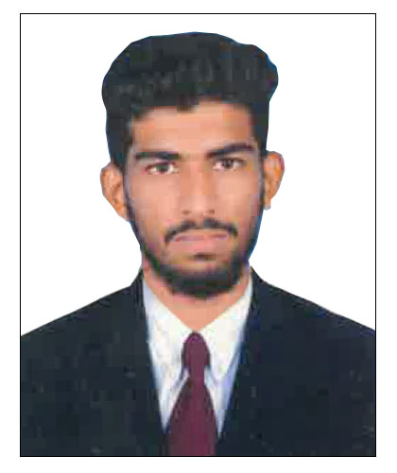
MUSTHAFA
musthafa-392177@2freemail.com

CAREER OBJECTIVE:

Seeking for a job to pursue highly rewarding career and healthy worker environment where i can utilize my skills and knowledge efficiently for the organization growth.
PERSONAL DATA:

Gender : Male
Date of Birth : 09/01/1998
Nationality : India
Marital Status : Single
Religion : Islam

EDUCATION:

Examination | Institution | University/ Board | Passing Year | Percentage
B.A | University College of Mangaluru, Hamanakatte | Mangalore University | 2018 | 64.32%
PUC | Govt PU College, Kurnadu, Mudipu, DK | Pre University Board | 2015 | 71.66%
SSLC | Govt High School Kadumata, Kolnadu, Bantwal, D.K | Karnataka Secondary Education Examination Board | 2013 | 56.32%

JOB EXPERIENCE:

- 06 Month work experience at Tally computer IT Company.
- 06 Month work experience sports shop.

Extra Activity:

- University Level Football and Tennis.

LANGUAGES:
- English
- Hindi
- Malayalam
- Kannada
Computer Skills : DICA
- Ms- Office
- Tally ERP9 (GST)
- Nudi 4.0
- Internet
Strengths:
- Confident outlook & Persistence
- Team Builder with positive mental attitude
- Learner, Adaptability

