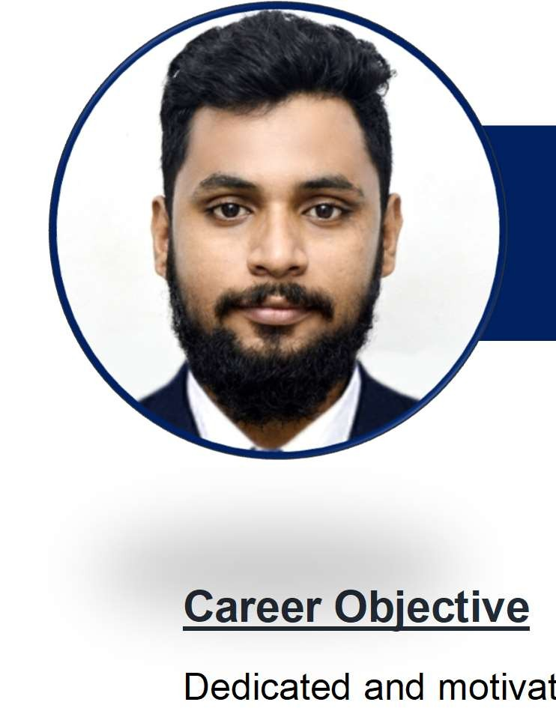

SAJID
PROJECT ENGINEER (INTERIOR & CIVIL)

Sajid-392198@2freemail.com

ted diploma holder having 5 years and 8 months experience in the field of civil engineering. Specialised in Interior Fit-out and design coordination. Seeking work in an organization which leverages my knowledge and experience into a role of Project management.
Career Objective
Dedicated and motiva

Work Experience
Nov 2018 – Projexon Project Management Consultancy Solutions LLP – Calicut, Kerala
Present Project Engineer
- Currently working as a Project Engineer and Auditor in finishing works.
- Preparation of Quality manual, Quality Plan, Environmental Health and Safety manual, Checklists.
- Completed a textile showroom project (22000 sq.ft) worth 2 crores with a span of 3 months.
- Coordination with planning, procurement, execution departments
- Continuous monitoring, recording and updating of documents kept at site - daily activity, labour register, material and labour allocation.
- Site visits and inspection of work on a regular basis.
- Updating of the various documents required for quality.
- Scrutinizing the reports received from site – Daily, weekly and Monthly reports.
- Continuous interactions with contractor and vendors involved with the projects

April 2014 – Kaza Infra Developers – Calicut, Kerala
October 2018 Site Engineer
- Worked as project engineer and site engineer for Infrastructure projects.
- Interior fit out Auditing engineer
- Completed and handed over a zoology Museum Interior Fit-out project worth 75 lakhs within 45 days.
- Timely completion of a project for the construction of a production factory owned by Malabar Rural Development Corporation worth 50 lakhs.
- Successfully completed the construction of a suspension bridge at Nilambur, Kerala worth
1.2 crores.
- Auditing and Interior construction of a conference hall and theatre for Indian Institute of Management

Academic Profile:
Aug 2011 – K.S Rangasami Institute of Technology, Erode
May 2014 Diploma in Civil Engineering (72%) Project Work
Design of a Multi-storied residential building
Jul 2009 – National Council For Vocational Training, Calicut
May 2011 Diploma in Interior Designing (70%) Project Work
Interior Fit-out of a 5 star hotel and a clinic
Aug 2006 – Government Vocational Higher Secondary School, Calicut
May 2009 Secondary School Leaving Certificate - (Grade 10) – 60 %
Awards and Achievements:
- Best Performer of the year - Kaza Infra Developers – 2016 Japan Karate Associations – Shodan holder (1st Black Awards and Achievements
- Best Performer of the year - Kaza Infra Developers – 2016
- Japan Karate Associations – Shodan holder (1st Black)
Awards and Achievements
- Best Performer of the year - Kaza Infra Developers – 2016

- Japan Karate Associations – Shodan holder (1st Black)

Soft Skills

COMMUNICATION MANAGEMENT COORDINATION DESIGNING

Software Skills
AUTOCAD

PHOTOSHOP 3DSMAX
MS OFFICE

GOOGLE SKETCH UP

Languages

English Malayalam Hindi Tamil

