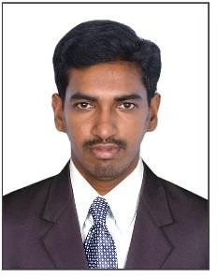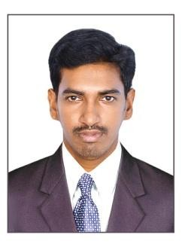AZARUDEEN

Email : azarudeen-392204@2freemail.com

OBJECTIVE

Seeking a good position in the areas of Logistics in a professionally managed organization, where in my skills sets, experience, value additions and opportunities from the organization will leverage the capacity to achieve in the challenging tasks and goals with the avenues of learning and growth.

PROFILE

- Qualified with Master in Business Administration ( Shipping &Logistics, Human Resource ) and holds Bachelor Degree in Business Management.
- A result oriented professional with 3.5 years of experience in Operations, Transport.
- Worked with BLACK BUCK- Zinka Logistics Solutions Pvt. Ltd. as Senior Executive–Operations.
- Abilities in managing the Operations as well as Transport activities.
- To attain excellence in the professional world by gaining experience and exposure and help the company grow in whatever way I can through hard work and determination.
- Confident, time management capability.
- Can work efficiently in a group as well as an individual.
- Conceptually strong with an innovative, detail-oriented and analytical approach to the work.
- Self-motivated, hardworking and goal-oriented with a high degree of flexibility, creativity and commitment.
SCHOLASTICS

- Master in Business Administration (Shipping & Logistics, Human Resource), CMS Academy Of Management and Technology, India.
- Bachelor of Business Management, CMS College of Science & Commerce, India.
- APGDCA- Advance Post Graduate Diploma in Computer Application, IMF Computer Education, India.

PROFESSIONAL EXPERIENCE

Organization : BLACKBUCK- Zinka Logistics Solutions Pvt. Ltd.
Designation : Senior Executive - Operations
Periods : 3 years and 7 months(From 22Sep 2015to 30Apr 2019)
CUSTOMERS HANDLED

  - Everest Industries Ltd.
  - Marico Ltd.
  - ITC Ltd.
  - Berger Paints.
  - Britannia Pvt. Ltd.
  - Jyothy Laboratories.
  - Jayanthi Spices.

RESPONSIBILITYAS TRANSPORT OPERATION

- Handling overall transport & logistic operations.
- Responsible for getting the right truck, right products in the right quantities, sent on the right customer to the right locations all at the right time.
- In charge of the day to day operations of the transport department.
- Efficiently managing a team of drivers and vehicles.
- Responsible for all of the dispatching, routing, and tracking of delivery vehicles.
- Dispatching complex and oversized goods to national and international destinations.
- Managing, monitoring and developing a team of drivers and line managers.
- Involved in strategic development and strategy making.
- Being the first point of contact for all drivers.
- Making sure that all transport fleet vehicles are properly maintained and serviced.
- Arranging for the induction and training off all new staff.
- Developing and nurturing customer relationships.
- Maintaining accurate administrative records.
- Organizing vehicle checks.
- Identifying operational issues, potential problems and opportunities.
- Resolving and managing queries and complaints courteously and efficiently.

- Appraising staff performance and also taking disciplinary measures when required.
- Coordinate with clients for necessary documents for Customs clearance.
- Solving the Problems related to Documentation.
- Updating the clients regarding the status of consignments from time to time.
- Preparing daily, weekly and monthly consignment statements and provide the same through e-mail to the clients.
- Coordinating with transport department of the organization to ensure timely delivery of the consignment to the clients.
- Coordinating with all branch offices located in different states.

ADMINISTRATION:

- Approaching Clients for business development.
- Assisted the collections department in obtaining outstanding customer debts.
- Ability to function in almost any scenario and go the extra mile to get the job done.
- Exceptional leadership and team building qualities in the training, mentoring.
- Motivating and supervising of supply chain, logistics, and transportation/warehousing.
TECHNICAL SKILLSET

- Operating Systems : Windows 95, 98, 2000, XP Professional.
- Word Processor :MS Word
- Spreadsheets :MS Excel.
- Computerized Accounting :Tally ERP 9.0
PERSONAL PROFILE

Date of Birth : 16-02-1992
Gender : Male
Marital Status : Married
Languages Known : English, Tamil and Malayalam
Nationality : Indian
Visa Status : Long term visit visa

