PERSONAL PROFILE

I am a principled Front Office Operations Administrator with quality IT experience who is committed, hardworking, honest with strong personality, excellent communication, interpersonal skills and reliable positive results.

PROFESSIONAL OBJECTIVES

I am determined to put in the very best of my experience and skills towards the goals and objectives of my employer observing competency through dedication, creativity and decision making based on the need to add value hence achieving the organizational set goals.

TECHNOLOGY SKILLS

I am proficient with extensive experience in handling customer care duties and services, data entry, office management record keeping and monitoring security awareness.

NANCY

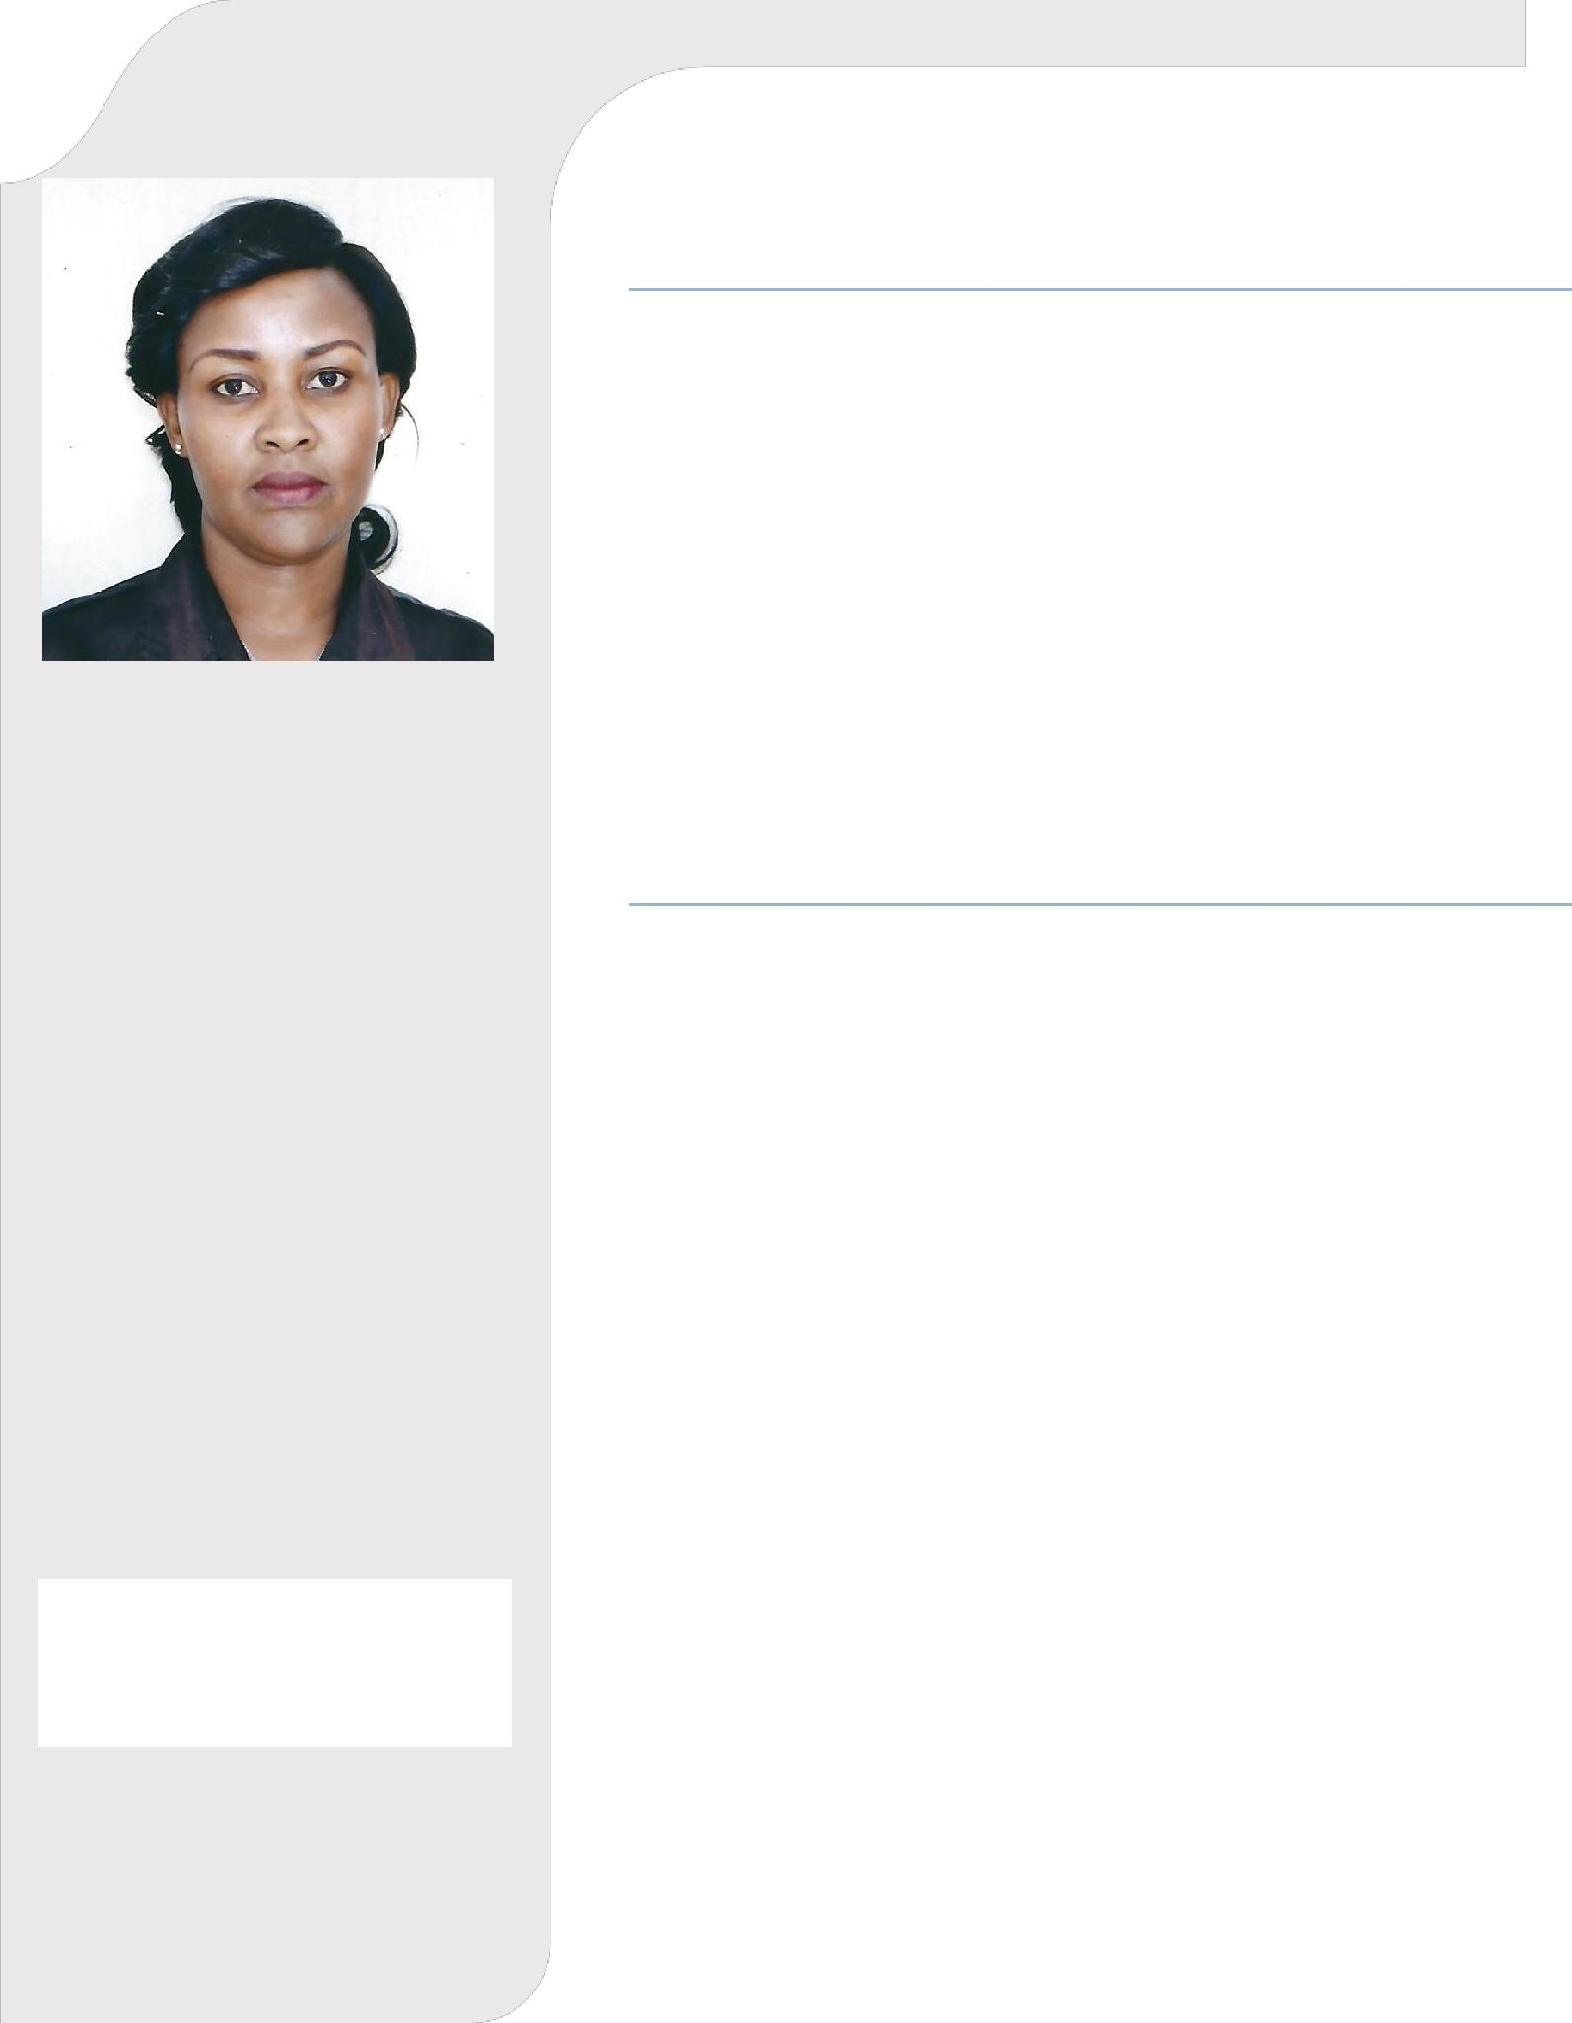

NATIONALITY | : | KENYAN
VISA STATUS | : | VISIT
E-MAIL | : | Nancy-392207@2freemail.com

EDUCATION
[2015 | – 2016] | Diploma in Information Technology | –
 |  | Strathmore University
[2011 | – 2012] | Diploma in Front Office Operations & Administration –
 |  | University of Nairobi
[2005 | – 2006] | Certificate in Information Technology | –
 |  | Wantech Computer College
[2001 | – 2004] Kenya Certificate of Secondary Education |  | –
 |  | Katutu Secondary School

WORK EXPERIENCE

Receptionist, {July 2014 – May 2019}

SEO & SONS LIMITED, Nairobi.

Duties and Responsibilities
- answer telephone, screen and direct calls

- provide information to callers

- greet persons entering organization

- direct persons to correct destination

- ensure knowledge of staff movements in and out of organization

- monitor visitor access and maintain security awareness

- provide general administrative and clerical support

- prepare correspondence and documents

- receive and sort mail and deliveries

- schedule appointments

- maintain appointment diary either manually or electronically

- organize conference and meeting room bookings

- co-ordinate meetings and organize catering

- monitor and maintain office equipment

- control inventory relevant to reception area

- tidy and maintain the reception area

Financial Advisor, {March 2012 – Sept 2013}

Britam Insurance, Yaya Centre Nairobi.

Duties and Responsibilities

- Conduct market research.

- Customize insurance programs.

- Assist clients in selecting products.

- Determine discounts and premiums.

INTERESTS

Travelling
Exploration
Photography

- File reports of numbers of insurance quoted.

- Lead insurance agents and track performance.

- Develop sales quotas and minimize company risks.

- Create and implement business strategies and goals.

- Plan advertising budget and appropriate advertising channels.

- Analyze statistical data, such as mortality, accident, sickness, disability, and retirement rates and construct probability tables to forecast risk and liability for payment of future benefits.

Sales Attendant, {June 2010 – Feb 2012}

Nakumatt Supermarket Jewelry Section, Mombasa.

Duties and Responsibilities
- Participate in receiving stock.

- Recommend and record daily sales.

- Participate in opening and closing duties.

- Clean and polish jewelry and arrange them neatly in display.

- Engage in providing courteous and rapid service to customers.

Library Attendant, {Nov 2007 – May 2010} Horticultural Crops Development Authority Resource Centre, Nairobi.

Duties and Responsibilities
- Maintain customer’s database.

- Responding to email enquiries

- Arranging books in Resource centre.

- Access information from the internet e.g. ITC’S market.

- Provide advisory services to customers who check in to the Resource Centre.

- Network with Stakeholders to review, collect and disseminate information.

Receptionist, {March 2006 – Feb 2007}

Tower Initiatives Nairobi

Duties and Responsibilities

- Maintaining the office diary.

- Transferring calls if necessary.

- Receiving and dispatching deliveries.

- Diary management of meeting rooms.

- Organizing office activities and events.

- Handle event coordination both internally and externally.

- Handle queries and complaints via phone, email and general correspondence.

- Maintain office services as required (such as cleaners and Maintenance companies).

- Taking and ensuring messages are passed to the appropriate staff member on a timely basis.

