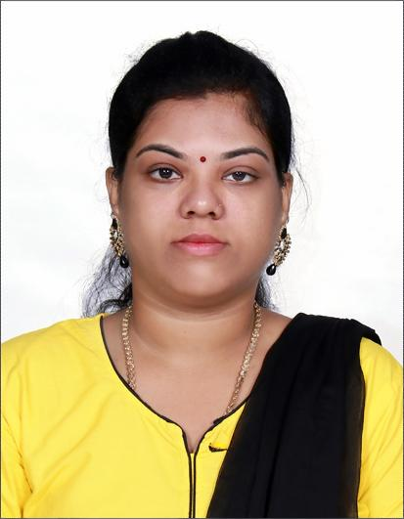
RESUME

Radhika
Radhika-392212@2freemail.com

OBJECTIVE

To work in an organization where my skills and knowledge can be utilized in successful completion of various assignments that will eventually help realize the goals of the organization and the individual.

STRENGTH

- Dedication and hard Working
- Strong communication and interpersonal skills and proven ability to develop and test with a software specification.

EDUCATIONAL QUALIFICATION

EDUCATIONAL  QUALIFICATION | INSTITUTION | YEAR OF PASSING | PERCENTAGE
SSLC | St.Helen’s girls higher sec school | 2003-2004 | 69%
HSC | Government higher sec school | 2005-2006 | 55%
B.Sc (Computer Science) | Vels College Of Science | 2006-2009 | 62%
M.Sc(Computer Science) | Vels University | 2009-2011 | 86%

VISA DETAILS

Visit Visa period for 3 months(30 Apr 2019 to 24 Jul 2019)

WORK EXPERIANCE

HINDHUJA GLOBAL SOLUTIONS- Customer Relationship Officer during (22 July 2012 to 01 Aug 2013)

OMEGA HEALTH CARE – AR Associate - AR caller during (18 March 2015 to 01 oct 2015)

SOFTWARE PROFICIENCY

- Packages : Ms Word, Ms Powerpoint

- Languages : .Net, C,C++,Vb

- Databases : Ms Access,Oracle,Oracle 10g, Sql Plus

- Tools : Web Page Designing(Html)

- Courses Done : Diplamo In Computer Applications, Oracle, Oracle 10g,.Net

- Operating Systems : Ms Windows98,2000,Xp,7

AREA OF INTEREST

- Software Field
- Web Designing,
- Administrative Jobs
However, I am willing to work in any challenging field

CO-CURRICULAR ACTIVITIES:

Industrial visit (Infosys Company at Shollinganallur).

PERSONAL HOBBIES:
- Drawing
- Learning New Things
- Browsing
- Reading Books

PERSONAL PROFILE

Date of Birth : 25-sep- 1988

Gender : Female

Marital Status : Married

Nationality : Indian

Languages known : English,Tamil

