SIDRATARIQ 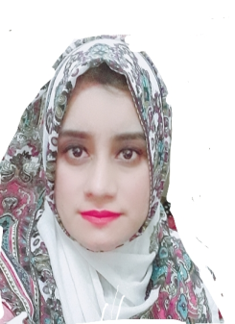
Email: sidratariq.392229@2freemail.com

Skills | Pharmaceutical storage awareness, Pharmaceutical distribution familiarity, Medication compounding expert, Drug Utilization review, Inventory management, understanding of Medicare and Medicaid processes,patient Counseling,proficient in Microsoft office,power point and Excel.
CAREER OBJECTIVE:
Patient service oriented Pharmacist with Doctor of Pharmacy degree. Strong background in clinical pharmacology,Patient medication therapy management and preparing formulations.
POST APPLIED FOR DHA REGISTERED PHARMACIST: Cleared DHA (Dubai Health Authority) Exam.

PROFESSIONAL WORK EXPERIENCE:
Organization: Marina pharmacy group, Iranian Hospital Dubai
Designations: Retail pharmacist
Tenure:One year(1 year)

Organization: Home Needs pharmacy,Family Facility Complex behind AFIC, Rawalpindi.
Tenure: 1st June 2015-30th June 2018
Designations: Retail pharmacist
Responsibilities:
- Accurately pulled medications from the shelves for replenishment and delivered them to the various patient care areas.
- Mixed various pharmaceutical preparations according to written prescriptions.
- Calculated, weighed, measured and mixed ingredients with expert precision.

Organization: Shaafi International Hospital, Islamabad
Tenure: 20th November 2014 -30th May 2015
Designations:Hospital pharmacist
Responsibilities: Entered new patient profiles and prescriptions into medication input software system

Organization: Hoover pharmaceutical industry. Lahore
Tenure:1st November 2012-31th May 2013
Designation: Dispensing pharmacist

Organization: Children’s Hospital and the Institute of child Health Lahore
Tenure: 1st January 2011-6th February 2011
Designations: Internee pharmacist
Departments: Total parental Nutrition (TPN) section, Allocated Wards, Outdoor patients (OPD) pharmacy
Organization: Global Pharmaceutical sciences Pvt Ltd.Islamabad Tenure: June 2011-August 2011 Designation:Internee pharmacist

ACADEMIC EDUCATION:
EXAMINING BODY: YEAR
Pharma-D (Doctor of pharmacy) Riphah institute of pharmaceutical sciences (RIPS) Islamabad 2007-2012
CERTIFICATIONS AND LICENSES: Licensed under Category A as a Pharmacist by PAKISTAN PHARMACY COUNCIL.
17th International pharmacy conference and Exhibition organized by Pakistan pharmacist Association.

