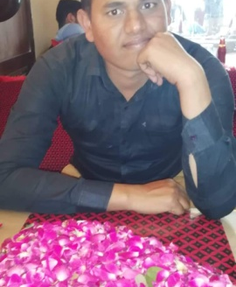
Afzaal

Email: afzaal.392233@2freemail.com

^{Career Objective}
To seek an opportunity in an environment to demonstrate and apply my professional knowledge and experience, meet challenging problems and participate actively in the development of the Organization along with career advancements.
^{Professional Skills}
- Well know about c.c.t.v operator
- Work as receptionist
- Strong speaking level of English

- MS office (Advanced Level)
- Strong Follow up

^{Experience}
Security guard Officer (02th jun 2015 – Till)
^{Security guard experience}
- Work as team leader in Marina terrace
- Work as security guard at Al nabooda building
- Work in Al ghurair exchange
- Work at ocean height
- Work at Al yousifi building supervisor
- Work at CCTV watcher ajmal building
- Defence place like warehouses Dubai metro TAV construction site

^{Education:}
B.A (continue): University of the Punjab Lahore
Intermediate pbte, Lahore
Matric (Science): BISE, Lahore

^{Personal Detail}
- Date of Birth 01-01-1992 Nationality Pakistani
- Language known English, Urdu & Punjabi
- Father Name: Muhammad Afzal Gender Male
- Marital Status Single Domicile Okara(Punjab)
^{Personal Highlights}

- Dedicated, hardworking individual with the confidence and good interpersonal skills
- Articulate, self-motivating and decision-maker.
- Willing to accept challenging responsibilities.
- Interested in learning new things with active understanding.
- Having good knowledge of documentation.
^{Co-Curricular Activities:}

- Playing games likes Football Cricket & Computer games
- Make Painting
- Keep myself up-to-date with latest technology trends in market.
- Surf Internet for latest technologies that I came to know time by time.
- Spending free time with family and friends.

