- MANJESH
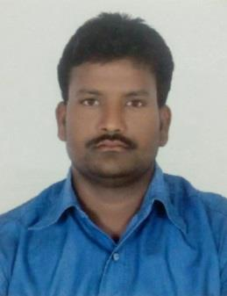
FOREMAN
Email: manjesh.392242@2freemail.com
CAREER SUMMARY :
- SEEKING ORGANIZATION IN NEED OF AN AGGRESSIVE, ENERGETIC, PERSON TO IMPROVE PERFORMANCE AND GET ON AN ORIGINAL AND INNOVATIVE PATH TO MAINTAIN THE TOTAL CONCEPT OF PERSONAL AND PROFESSIONAL SERVICE.
- HIGHLY MOTIVATED, DEPENDABLE AND HARDWORKING WITH GOODN SKILLS, COMMUNICATION AND COORDINATION.
WORK EXPERIENCE:
- CARPENTER FOREMAN 2010 TO TILL DATE.
EDUCATIONAL QUALIFICATION:
- MATRIC
PROJECT COMPLETED
- JABEL HAFEET VILLA ALAIN
- ABRAJAL RAHA TOWER ABU DHABI
- ADNIC ALRAHA TOWER ABU DHABI
- ROTANA HOTEL ALAIN
- AMMROC ( ADVANCED MILITARTY MAINTAINACE REPAIR AND OVERHAUL CENTER ) ALAIN

NATURE OF DUTIES
- ABILITY TO PLAN AND PRIORITIES WORK ACTIVITIES EFFECTIVELY
- EXPERTISE IN SHUTTERING WORK OF FOOTINGS,COLUMNS,BEAMS,SLABS,LIFT SHAFT WALLS,GRADE SLAB,STARI CASE.RETAINING WALL ETC.
- EXPERTISE IN FIXING ANCHOR BOLTS AND ALL KIND OF FINISHING AND SNAGGING WORKS.
- EXPERTISE IN TRENCH GRATINGS AND RELATED SHUTTERING WORK.
- ABILITY TO WORK LONG HOURS AND EXCELLENT ABILITY TO DO MULTI TASKS.
- EXPERTISE IN FIXING DOOR FRAMES AND DOOR PANELS INCLUDING FINISHING WORKS LIKE GROUTING.
- EXPERTISE IN HANDLING THE WHOLE TEAM AND KNOW HOW TO FINISH THE WORKS AS PER TARGETS.
- EXPERTISE IN GIVING PRE TASK BRIEFING TO THE WORKERS ABOUT SAFEFTY.
- ENSURING SAFE WORKING ENVIRONMENT IN ACCORDANCE WITH THE SAFETY PALNS.

PERSONAL DETAILS:
DATE OF BIRTH 08-03-1985
SEX MALE
NATIONALITY INDIAN
LANGUAGE KNOWN ENGLISH AND HINDI

MARIETAL STATUS MARRIED

