ROHIT

Email: rohit.392248@2freemail.com

~ Project Management, Planning, Contracts, Claims & Cost Control Initiatives ~
ACADEMIA
Masters Degree in Advance Construction Management from National Institute of Construction Management & Research,
Pune in 2007.

Bachelor's Degree in Civil Engineering (Full Time) from Dr. P.G.H. Collage of Engineering & Technology, India in 2005.

Associate Chartered Institute of Arbitrators (ACIArb)

IT Skills: Primavera Project Planner – P6 Ver. 8.3, Microsoft Projects, MS Office (Word, Excel, PowerPoint, etc.), Candy Construction Software, Microsoft ERP.
OTHER COURSES

- Currently pursing MRICS from Royal Institution of Chartered Surveyors, UK.
- Pursuing Membership of Chartered Institute of Arbitrators (MCIArb)
- Primavera 6 Ver. 16.3 Basic / Advanced and Cost Loading training from CMCS, Dubai.
- 1 week training on Candy Construction Software for Project Planning and ERP Implementation.
- Project Management Training for PMP Preparations from MMI, Doha, Qatar

PROFESSIONAL SNAPSHOT
- More than 14 years of experience in the field of Construction Planning, Project Monitoring & Controls, EOT Claims, Contracts, Cost Claims, Quantity Surveying, Cost Control, and Sub contract Management, Analysis of Profit/Loss Account for projects, Tendering & bidding for mid-size projects, Project Planning, Scheduling & Monitoring and Project Execution.

- Strong negotiation & analytical skills with the ability to network with Project Members, Client, Consultants, Sub-Contractors with consummate ease and working in Indian and International Environment.
- Competent in project management from conceptualization to initiating, planning, executing, monitoring & controlling and closing processes. An effective communicator with exceptional analytical, negotiation, relationship management and problem solving skills.

CAREER HISTORY

  - From July 2010 until July 2016 with Redco Construction – Almana, Qatar as Manager – Planning & Contracts
  - From Feb 2008 until June 2010 with Habtoor Leighton group as Sr. Planning Engineer
  - From July 2006 until Jan 2008 with Vascon Engineers as Sr. Planning & Cost Engineer
  - From Jan 2005 until Jun 2006 with Mfar Construction, Bangalore (India) as – Project Engineer

1

ACCOUNTABILITIES / JOB DESCRIPTION

Planning:

- Responsible for the preparation of Contract Programme for the project; including the recourses & cost loading.
- Preparations of the “S” Curves for time & cost and monitoring of the same on weekly & monthly basis.
- Generating the monthly invoices from Primavera from Earned Value Method.
- Developing & monitoring the Engineering / Procurement schedules including the key project deliverables.
- Preparing the Recovery / Revised Programs as and when required.

Claims Management:

- Drafting the claims for the delays suffered due to various reasons. Responsible for preparation of Contractor’s Time Extension Claims, to carry out the forensic delay analysis.
- Estimating & claiming the Prolongation Cost to client, arranging the necessary documents to substantiate the cost.
- Submitting the delay analysis on regular basis in line with contract requirements.
- Evaluation of claims submitted by the sub-contractors.

Contracts Administration:

- Managing contract variations, claims, disputes and payment conditions and coordination of Close-out and agreement/settlement of final account
- Preparing:
  - Progress payments against work completed and liaising with senior quantity surveyor on formal cost reporting.
  - Construction programme for projects within frame of FIDIC with the help of project management tool.
- Reviewing, evaluating and finding difference between tender drawings with issued for construction drawings & further approved shop drawings, preparing takeoff quantities for structural & architectural finishing, raising the variation claims to clients.
- Awarding the sub contract works, preparation of sub contract agreements, reviewing the variations / claims arising from sub- contractors, processing sub-contractors monthly invoices.
- Assisting the Tender Department in tendering & bidding for various projects, preparing the base rate of various construction elements for future tenders based on current market prices and future prices escalations & inflation.
- Attending the Dispute Adjudication Board meetings, negotiating with clients/ arbitrators for disputed claims.
- Attend project meetings where necessary and provide advice on commercial and contractual issues.
- Provide the necessary guidance to members of the contract administration team on contractual and commercial issues.

Cost Control & Productivity Monitoring:

- Labour, Plant & Equipment, Material Control, preparation of Cost Reports on weekly basis to discuss in weekly Project Control Meetings.
- Preparing the cost control budget for the year & monitoring the same throughout the year
- Preparing the Weekly & Monthly Productivity Reports and monitoring the same, analysis of slippage and notifying to project managers for corrective actions.

2

PROJECTS

Projects involved in UAE, KSA & Qatar

- Bvlgary Hotel & Residences at Jumeirah, Dubai (scope includes 6 residential towers, 2 hotel blocks & services areas)
- Address Residences – Fountain View , Downtown, Dubai (scope includes three towers of G+7P+71 floors)
- Address Residences – Sky View , Downtown, Dubai (scope includes twin towers of G+60 floors)
- Abu Dhabi International Airport- Midfield Terminal Building)
- Business Bay Hotel by Aabhar, Dubai (scope includes twin towers of 45 floors)
- Construction of 68 number Skywalks at King Abdullah Financial Districts, Riyadh – KAS
- Construction of Riyad Metro – Line # 04 & 06, Riyadh- KSA
- Meshereib Downtown Development – Phase1,2 & 3 – Doha, Qatar
- Construction of Sukhoon Tower – Bahrain
- Construction of Mixed-Use Development at Worli - India (G+7P+73)

Projects involved in Qatar with Redco Construction – Alamana

- Construction of Hospital Building & Associated Infrastructure Works for Hamad Medical Corporation
- Construction of Five Star Hotel (Dusit Thani) in Al Khail District, Doha
- Abraj Quartier Gateway Tower (AQ-01 & AQ-02) @ The Pearl Qatar (2B+G+43)
- Viva Bahriya 11 @ The Pearl Qatar (2B+G+19)
- A Commercial Tower consisting of (2B+G+Mezz+ 57)

Projects involved in UAE with Al Habtoor Leighton

- Construction of Capital Gate Tower consisting of ( B + 2G+ 2Mezz + 45) for ADNEC, Abu Dhabi - UAE

Projects in India

- Philips Innovation Campus, Bangalore – India (cluster of midrise buildings)
- Construction of IT Park at Pune – India

PERSONAL DOSSIER

Date of Birth: 18th March 1984
Gender: Male
Languages Known English, Hindi, Marathi, Kannada Nationality: Indian
Visa Status: Residency Visa
Driving License: UAE & Qatar
Marital Status: Married

3

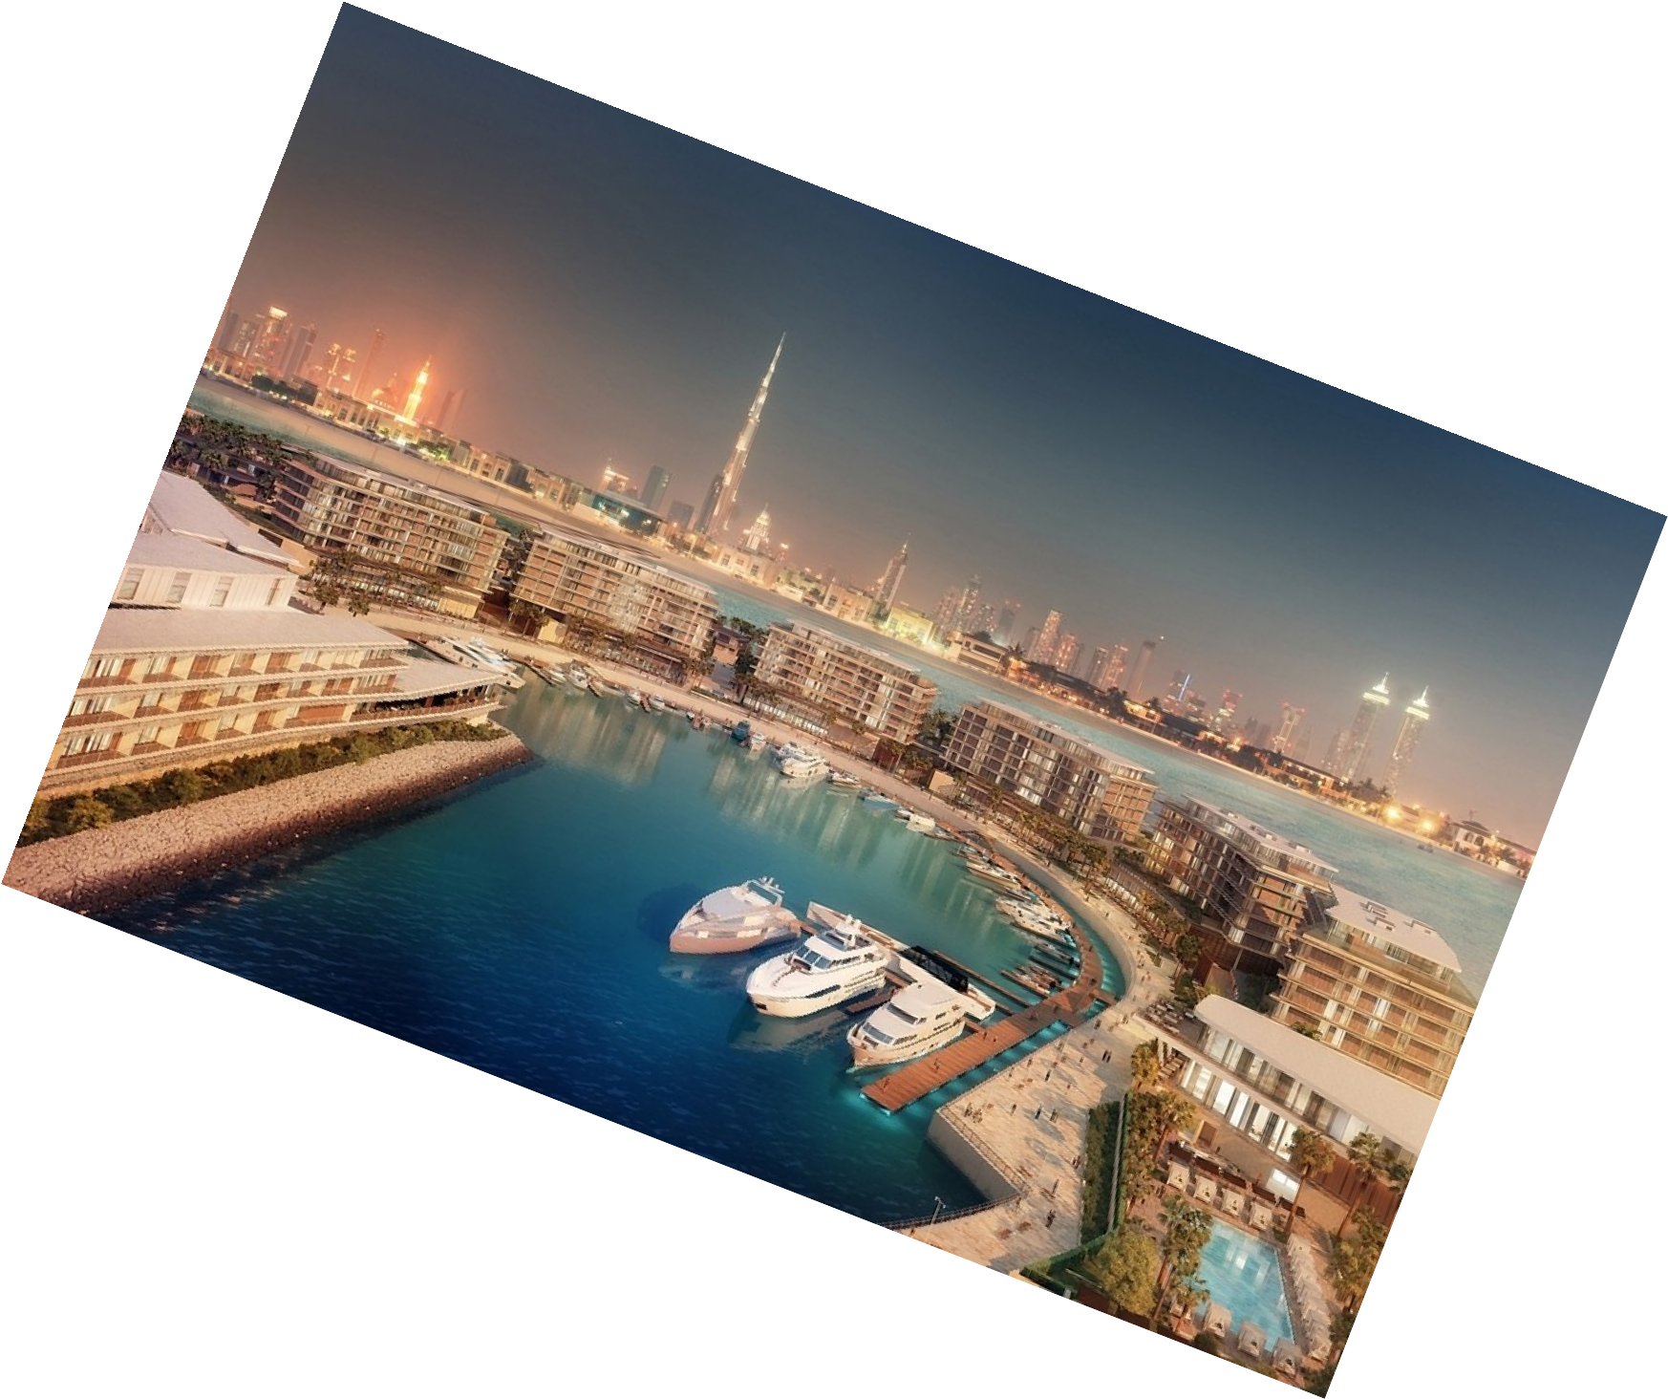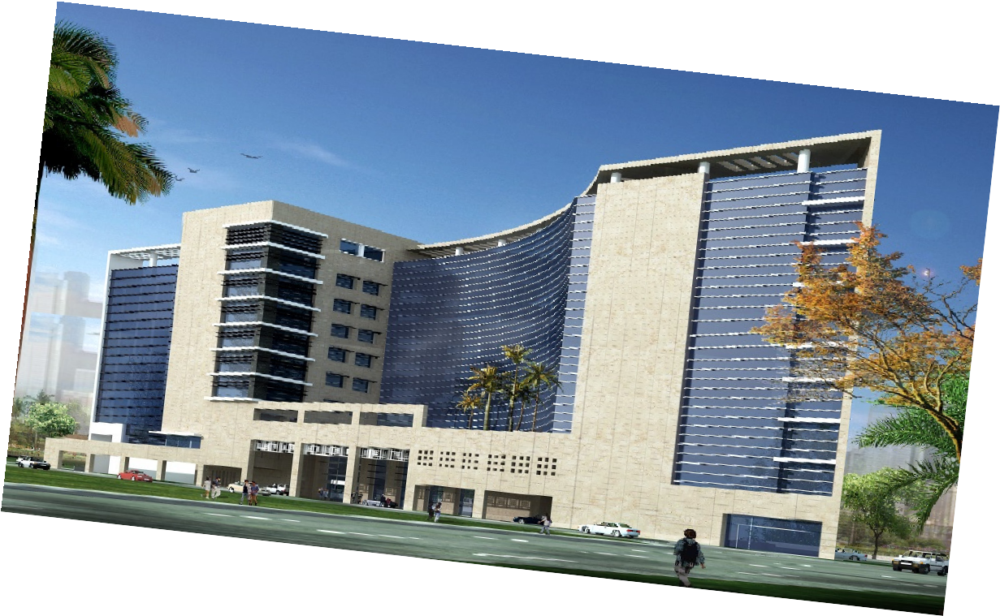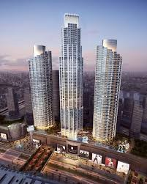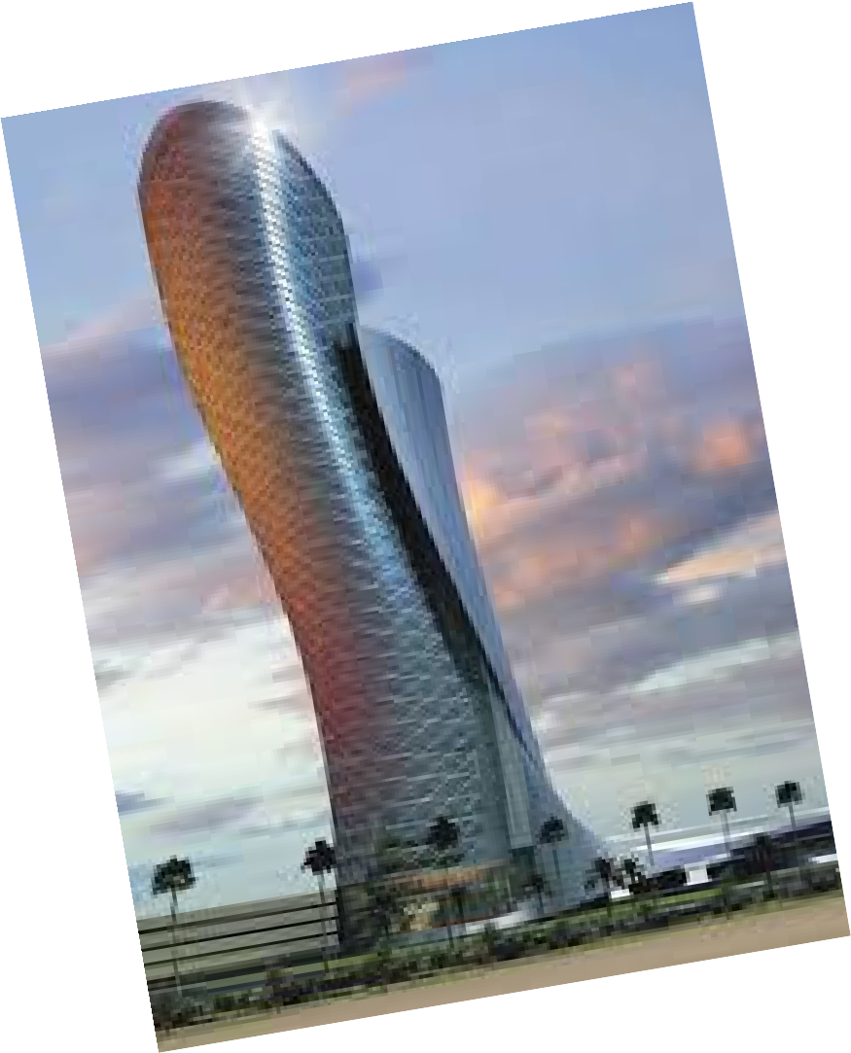

4

