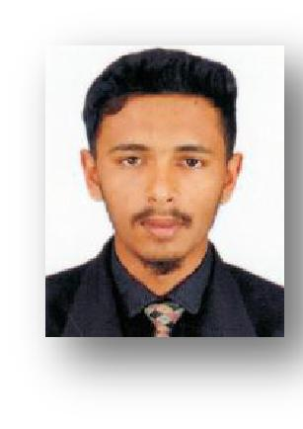
CURRICULUM VITAE
FAHAD
Fahad.392264@2freemail.com

 | Career |  | Seeking a challenging and rewarding career in a diverse environment where my hard work, ethic,
 | Objective
 |  |  | education and expertise can be used to achieve the mission of the company and exceed the team
 |  |  | goals.
 | Personal
 | Information
 |  |  | • | Date of Birth | 17th July 1997
 |  |  | • | Age | 21 years
 |  |  | • | Marital Status | Single
 |  |  | • | Gender | Male
 |  |  | • | Nationality | Sri Lankan
 |  |  | • | Education | 1. B/AL Murshid Maha Vidyalaya (O/L)
 |  |  |  |  | 2. Dharul Hasanath Academy Warakapola (A/L & AAT)
 | Professional |  | ❖ AAT (Pass Finalist PF NO:26422)
 | Qualifications
 |  |  |  | ➢ Level 1 – Completed
 |  |  |  | ➢ Level 2 - Completed
 |  |  |  | ➢ Level 3 – Completed
 |  |  |  | Talent (skills) capstone –
 |  |  |  | Effective Communication Skills (English) – A
 |  |  |  | Information Technology Skills – B
 |  |  | ❖ CMA (Reading)
 |  |  |  | ➢ Foundation level – Completed
 |  |  |  | ➢ Operational level – Completed
 | Academic |  |  | ➢ Managerial level | – Reading
 | Qualifications |  | • | General Certificate of Education (O/L) Examination-2013.
 |  |  |  | (Medium- Tamil)
 |  |  |  | (34326804)
 |  |  |  | A grade in 1 subjects
 |  |  |  | B grade in 2 subjects
 |  |  |  | C grade in 2 subjects
 |  |  |  | S grade in 4 subjects
 |  |  | • General Certificate Of Education (A/L) Examination-2017
 |  |  |  | (Medium- English)
 |  |  |  | (7408854)
 |  |  |  | C grade in 1 subjects
 |  |  |  | S grade in 2 subjects

 |  |  | • October 2017 – June 2019 at Micronet Global Services (PVT) LTD.
 | Working Experience |  |  | Accounts executive
 |  |  |  | ➢ Report immediately to the project manager in the management department with
 |  |  |  | regard to Accounts receivable and Accounts payable as daily basis.
 |  |  |  | ➢ Coordinate with the Manger and Team leader with regard to long outstanding
 |  |  |  | payable and receivable.
 |  |  |  | ➢ Preparing interim and final Bank reconciliation statements.
 |  |  |  | ➢ Verified invoices and records for accuracy and completeness.
 |  |  |  | ➢ Analyzing and interpreting financial data.
 |  |  |  | ➢ Preparing and submitting the month end reports to Project manager.
 |  |  |  | ➢ Issue of cheques and make the cash payments with Project manager’s approval.
 | Computer Literacy
 |  |  | • | Windows operating.
 |  |  | • | Application packages
 |  |  |  | ➢ Microsoft office.
 |  |  | • Familiar with Oracle and JDE accounting package.
 | SKILLS& |  | • Proven ability to work independently and in a team as appropriate.
 | STRENGHTHS
 |  |  | • Ability to provide leadership for teams and multi-tasking.
 |  |  | • Willingness to share and adopt skills.
 |  |  | • Understand, speak, write and read English, Sinhala and Tamil.
 | Awards & |  | • Diploma in Accounting & Business.
 | Achievements
 |  |  | • championship of annual sports meet
 | Extra |  | • | Member of SSR welfare society ( Reg No: 3/4/3-244 Weli )
 | Curricular |  | • | Leadership in school.
 | Activities
 |  |  | • Participated in cultural events.

I certify that the statements made on this application are strictly true & accurate in every detail. I have not wittingly withheld any information which might be to my disadvantage in this application. I agree, if engaged, to accept all the rules & regulations of the company.

Fahad

