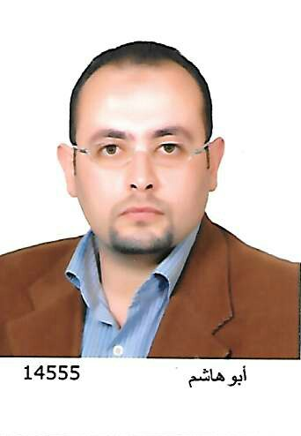
Curriculum Vitae
CurriculumVitae

Personal Information:

-Name: Yassin Hegab
-Date of Birth: 29-09-1979
-Marital status:Married
-Nationality: Egyptian
-E.mail: yassin-392266@2freemail.com
-Language Skills: Fluent in English, French and Arabic.

Qualifications:

1) Primary Medical Qualification:
- M.B.B.Ch. (2002), from Faculty of Medicine, Zagazig University, Egypt.
2) Higher Medical Qualification:
- M.Sc. in Ophthalmology (2007), Very Good from Faculty of Medicine, Zagazig University, Egypt.
3) Fellow of Royal College of Surgeons of Glasgow (UK) 2012
4) Consultant from Egyptian ministry of health.
5) HAAD license Active

Surgical skills:

Surgeon
- Anterior segment:

1 Phacoemulsification: working with different phaco techniques and familiar with many machines (Over 1000 cases with special strength in operating hard cataract)
2 Secondary IOL implantation
3 ECCE and ICCE.
4 Glaucoma filtering surgery (conventional Trabe and non penetrating procedures).

- Oculoplastic surgery:

1 Lacrimal surgery (DCR, Intubation and dacryocystectomy)
2 Lid malpositions

- Pediatrics:

1 Stabismus (horizontal and vertical muscle surgery)
2 Congenital cataract
3 Buphthalmos including Ahmed valve implantation

Laser procedures:PRP, YAGcapsulotomy, P.I, argon laser suturelysis and lashes epilation by argon laser.

Refractive:

LASIK
PRK
Cross linking

Medical Retina:

Fluorescein retinography and interpretation
Optical coherence tomography and interpretation
PRP & focal laser
Avastin injections

Managing emergency cases such as rupture globe.

Assistant:

- PKP
- Conventional retinal detachment
- P.P.Vitrectomy

Present position

Ophthalmology specialist at NMC Ruwais Hospital

Previous Posts:

Ophthalmology Resident in Ophthalmology department, Zagazig University Hospitals, Egypt

Ophthalmology specialist in Zagazig Eye hospital, Ministry of Health, Egypt

Ophthalmology specialist, Magrabi eye hospitals , Saudi Arabia

I) Title of post: Intern (House officer).

1 At Zagazig University Hospital (University teaching Hospital).
2 Period: March 1st, 2003 to February 28th, 2004(one year).
3 Job description: included rotation of 2 months in the following departments: (Internal medicine, General surgery, Obstetrics & Gynecology, Pediatrics, Causalities and Ophthalmology).

II) Title of post:Ophthalmology Resident (SHO).

1 At Zagazig University Hospital.
2 Period: 31/8/2004 to 30/4/ 2007, full time.
3 Job description: Basic ophthalmology training included outpatient clinic activities as well as surgical training with rotation in the following departments:
1- Anterior segment unit (9 months).
2- Posterior segment unit (6 months).
3-Oculoplastic unit (9 months).
4-Investigative Ophthalmology unit.

III) Title of post: Ophthalmology Resident

At Zagazig eye hospital, Zagazig
Period: 5/7/2007 to 1/12/2007
Job description:
Resident supervision.
Student teaching.
Research work.
Weekly surgical list.

Title of post: Qualified ophthalmology resident

At Zagazig eye hospital, Zagazig
Period: 2/12/2007 to 28/2/2009

Title of post: Ophthalmology specialist

At Zagazig eye hospital, Zagazig
Period: 1/3/2009 to 1/11/2012

Ophthalmic Societies Memberships:

1 Ophthalmological society of Egypt.
2 Delta ophthalmological society.
3 Egyptian society of cataract and corneal diseases.

Research:

The title of M.Sc. Thesis was: Refractive changes After Pterygium Excision

