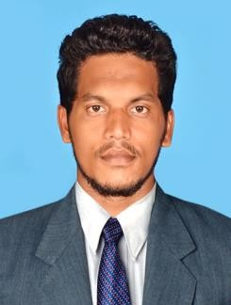
PRINCE SEELAN .P

CIVIL ENGINEER

E-mail : prince-392268@2freemail.com

Nationality : Indian
Visa Type : Visit Visa(Expiry on 10-09-19)
Executive Summary

A Civil Engineer with 3 years of experience, in the field of planning and execution of works as per design and drawings, Maintaining quality standards for all structural works, and contribute to the enhanced pride and reputation of the organization.
Strengths

- Decision making
- Scheduling work
- Recording Information
- Thinking Creativity
- Building Construction
- Leadership skills
- Co-ordination and Organization
- Health & Safety.

Educational Qualification

Bachelor of Civil Engineering - Passed on 2016 with 67%
Sathyabama University, Chennai,India.

Professional Experience

Civil Site Engineer - April 2016 - May 2019
Engineering Construction, Nagercoil, India.

Project undertaken : Residential Buildings,
Commercial Buildings.

Roles and Responsibilities

    - Read blue prints and plans and communicated them to supervisors.
    - Preparing the total quantities of construction materials as per approved drawing.
    - Maintaining the measurement of completed works.
    - Coordinating with subcontractors and client consultant related to project activities.
    - Attend progress and site co-ordination meeting with the clients and subcontractors.
    - Preparing Daily Report for client/ Consultant
    - Preparing Weekly Report for client/ Consultant
    - Preparing Monthly Report for client/ Consultant
    - Maintaining the daily construction activities and records.
    - Site Health & Safety.
Personal Details

Name : Prince Seelan.P
Date of Birth : 22nd March 1994
Gender : Male
Language Known : English,Tamil,Malayalam&Hindi Marital Status : Single
Nationality : Indian

