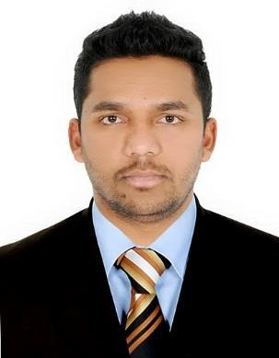
SACHIN
Email: sachin.392275@2freemail.com

Address: Dubai, UAE
Visa Status : UAE Work Visa

ACCOUNTS & FINANCE EXECUTIVE – MBA in FINANCE & MARKETING
Dedicated to Accuracy, Automation, Financial Control and Performance Excellence

- An Accounts Executive with 3+ years professional experience in UAE & INDIA

- Analytical accounting professional with proven track record in Accurate Preparation, Analysis and reporting of financial performance

- Worked with various applications such as PACT, SAP, Tally (ERP 9) and IBM SPSS

- Process driven with focus on Efficiency & Productivity

- Taxation and VAT system working experience.

SKILLS & EXPERTISE

✓ Accounting principles | ✓ Journal Entries | ✓ General Ledger
✓ Financial Reporting | ✓ Financial Concepts | ✓ Financial Analytics
✓ Client Coordination | ✓ Payment Processing | ✓ Financial Statement
✓ Financial Control | ✓ Account Reconciliation | ✓ Weekly/Monthly reporting

PROFESSIONAL EXPERIENCE

DISTINGUISHED REAL ESTATE
ACCOUNTANT February 2016 - Present

- Post and process journal entries to ensure all business transactions are recorded and maintains vendors’/suppliers’ records and ledger.

- Process vendor and supplier invoices, in a timely manner, verifying accuracy, approvals and account coding in accordance with company requirements

- Identifying invoice that are overdue or not been received to follow-up and process

- Responsible for processing all the incoming client requests within the given time frame to meet the SLA in accordance with payment terms, payment methods and quality standards.

- Generate daily, weekly & monthly reports and resolving open issues with purchase order, invoice, or payment discrepancies documentation and Posting the verified invoices.

- Assist in the processing of balance sheets, income statements and other financial statements according to legal and company accounting and financial guidelines

- Excellent strategic planning skills and able to interact with all levels.

- Perform any additional duties assigned by the Financial Accountant, Chief Accountant and the Management.

- Verifying and checking expenses claims.

Page 2

ACCOUNTANT (Internship) May 2015 – Sept 2015

■

■

■

■

■

■

■

■

■

■

■

■

Responsible for entire revenue/accounts process from manufacturing till delivery of goods.

Managed a team of 12 staff under my supervision for a smooth process.

Prepared daily journal and ledger entries.

Assisted with month-end financial reports

Help with accounts payable and bank statement reconciliation

Assist the senior team during audits

Done Balance sheet reconciliation

Work with the finance team on yearly forecasting efforts

Manage the monthly tracking of our physical inventory

Support the payment processing team

Done the data entry into system

Preparing Sales reports, income and loss statements and balance sheet account reconciliations at the end of the month.

EDUCATION

Master’s in Business Administration (MBA) | 2013 - 2015

Finance & Marketing

St. Aloysius Institute Of Management and Information Technology (AIMIT) Mangalore.

Bachelor Of Commerce (B.Com) | 2010 - 2013
Dr. A.V.Baliga College Commerce Kumta, Karnataka University.

PERSONAL INFORMATION

Date of Birth 30-05-1992
Nationality Indian
Visa Status UAE Work Visa

