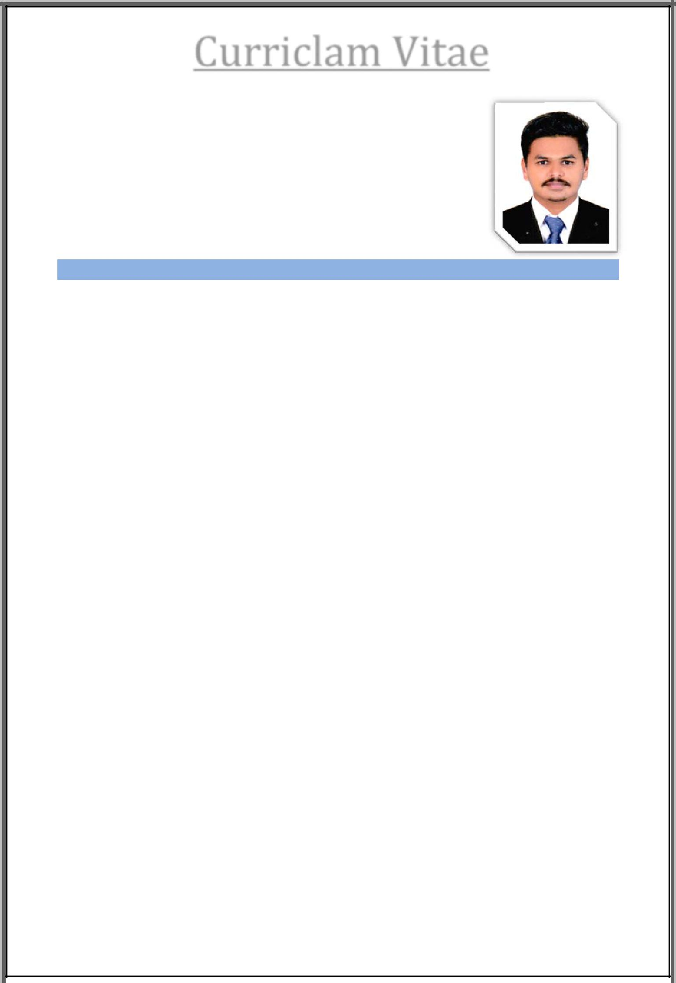
Curriclam Vitae

SAJIR

E‐Mail: sajir.392276@2freemail.com

CAREER OBJECTIVE

I wish to attain suitable position in an esteemed organization and who wish to use all my constructive abilities and desirous to make my career by changing my quality of work as demand to achieve the desire result. I sincerely believe in maintaining a peaceful, friendly and respectable atmosphere at my place.

EDUCATION

- PGDERP (Post Graduate Diploma in Enterprise Resource Planning). IPA in Kerala
Details in‐

  - Accounts Management

  - Inventory Management.

  - Tax Management.

  - Payroll Management.

  - MIS Reporting.

  - Advanced Tally ERP 9.0

- Microsoft Office Specialist

  - Specialist in Microsoft Office 2010 ‐ Excel

- BBA (Bachelor of Business Administration).

  - Specialized in HR (Human Resource Management.)

University of Calicut, Calicut, Kerala.

- Higher Secondary Education.

- Secondary Education.

Sajir C.V 1

WORK EXPERIENCE

- STEPPING STONE ACCOUNTING CONSULTANCY.

I have been work experience as an Account for 01 year.

Duties and responsibilities.

  - Software used in SAP

  - Prepared Cash Book, Bank Book, General ledgers, Purchase Book and Sales book.

EXTRA SKILLS

- Advance education in Micro Soft Excel, holding Certificate.

- Advance in Accounting Software such as SAP FICO, Tally, Quickbooks and Peachtree.

- Holding Quickbooks Certificate.

- Holding Tally ACE Certificate.

- ERP concepts and Environment.

- Specialized in Gulf Vat Accounting and holding Certificate in Gulf VAT Accounting.

COMPUTER SKILLS

- Operating system: Proficient in windows XP, Windows‐7 and Windows 10 operating systems.

- Application: Proficient in MS office and Microsoft office excel.

PERSONAL PROFILE
Date of Birth | : | 11‐11‐1997
Nationality | : | Indian
Marital Status | : | Single
Languages Known | : | English and Hindi
 |  | Malayalam and Tamil.
Visa Status | : | Visiting.

DECLARATION

I hereby declare that the above‐mentioned statements are true and correct to the best of my knowledge and belief.

Sajir CV

Sajir C.V 2

