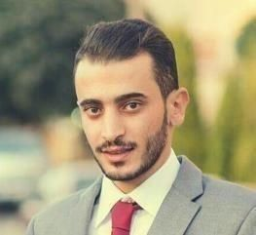
Omar
Omar-392282@2freemail.com

Bachelor Degree of Civil Engineer awarded by Al-Balqa
Applied University-Faculty of Engineering Technology (FET) on January- 2017

PERSONAL INFORMATION

Name : Omar Sameeh Abu Douleh Nationality : Jordanian
Birth Place : Amman - Jordan Marital Status : single
Driving License : UAE Driving License

CAREER OBJECTIVE

Seeking a Civil Engineering position to gain the real site experience and build my skills, which move me up to seniority level.

EXPERIENCES

- November 2018 – June 2019
Al Bunyan Wa Al Tameer Building Contracting ( United Arab Emirates - Sharjah)

February 2017 – August 2018
Emaar contracting company (Amman –Jordan)

Projects:
- ABC BankProject
- Abu AlandaMall
Main Tasks:
- .Interpret and execute construction drawings onsite
- Using project management tools, Responsible for assigning tasks to labours according to priorities in order to meet the timeschedule.

September 2016 – December 2016
Emaar contracting company (Amman –Jordan)

University onsite training: Updated Technical Contracting (UTC) as quantity surveyor, technical support and quality control engineer and Buildings plastering work.

GRADUATION PROJECT

Structural design to ACI-code .

COMPUTER SKILLS
- Primavera6
- AutoCAD
- MS ProjectManagement
- MSExcel
- MSWord

LANGUAGES
Arabic: Native Language English: good

I have good ability to do and to be :
- Responsible
- Timemanagement
- ProjectManagement
- PeopleManagement
- Have excellent ability to communicate the projects between project management and labours
- Analytical thinking with demonstrated talent for identifying, scrutinizing, improving, and streamlining complexwork.processes.

