CURRICULUM VITAE

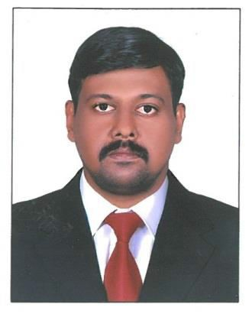
SAJAN
UAEExperienced6 years
EMAIL: sajan.392308@2freemail.com

CAREER OBJECTIVE
Lookingforwardanexcitingandchallenging careerfor further professionaldevelopmentandhencein thedevelopment oftheorganizationwhereIamplaced.

SUMMARY OFSKILLS
- ExperienceinLogisticManagementandproduction.
- Detailed-oriented,organizedandcomputer literate.
- Excellentdataentry,communicationandcoordination skills.
- Outstanding clerical,administrativeandproblemsolvingskills.
- Skilledinworkingunder stressful condition,managetimeandhandlingwarehouse operations.
- WellversedDocumentation(Invoice,PackingList,and AWBB/L ,Certificateof Origin).
- Goodverbal andwrittenskills&Telephonemanners.
- Computer Proficiency(MSDos,Windows,MS Word,MS Excel,
MS PowerPoint,MS Access,Internet&Email)inDocumentPreparation.

WORK EXPERIENCE
Workingas aDocument Controller.
FromApril 2018- Till present

- Coordinatingofficeactivitiesandoperationstosecureefficiencyandcompliancetocompanypolicies.
- Supervisingadministrativestaffanddividingresponsibilitiestoensureperformance.
- Keepstockofofficesuppliesandplaceorders whennecessary.
- Managinginventory, fillingrequisitionformandcoordinating with
productionandsalesdepartment.
DocumentationSpecialist
January 2015– May2017

- Supervisingloading and unloadingofshipment andstockingofgoods.
- Collectingandverifying purchaseordersfrom production andotherdepartmentsfor placingorders.
- Preparingdelivery schedules and confirmedarrival of shipmentfromvendors.
- Performingdataentry andupdating salesandpurchaseorders.
- Creatingbillsofladingandcertificateoforiginfor shipment.
- Communicated with clients and updatedthemaboutfreightpickupanddeliveries.
- Performedphysical counting onincominggoodsandlocalauthorities fordeliverypermits.
- Sortedoutgoodsdamagedintransit and informedvendorsfortakingthemback.
- Updatedrecordsofinventory,production,salesandlocation.
- Arrangedandcoordinatedshipmentprocessandmonitoredtransferofgoods.

AccountsAssistant
October 2012–December2014

- Tomanageday to day operationsoftheaccounts department.
- Tomanageaccountspayable(billpayments,salaries, petty cashetc.)
andreceivable throughcash/ cheque/voucher ina timely manner.
- Toestablishandmaintainfiles andrecordstodocumenttransactions.
- Tomaintainandreconcilecash/financialaccounts
- Enter andcodefinancial transactions appropriately.
- Process payments as wellas documentslikeinvoices.
- MakeandTrackPayments.
- Validateinvoicesagainst items orservicesreceived.
Checkall financialtransactions foraccuracy

EDUCATIONALQUALIFICATION

CERTIFICATE | NAMEOFINSTITUITION | YEAR
Shipping&LogisticsManagement | InsightSchoolofEngineeringandManagement | November2017
Higher Secondary(P.C.M.B) | StJoseph’sHss,Trivandrum,Kerala | June2002
Secondary School Leaving Certificate(SSLC) | StJoseph’sHss,Trivandrum,Kerala | May2000
COMPUTERCERTIFICATES
Computer HardwareandNetworking,Comptia A+, MCP (Microsoft Certified Professional), MCSA (Microsoft Certified System Administrator),MCSE (Microsoft Certified System Engineer),Tally.

PERSONALPROFILE

Date of Birth | : 02-05-1984, 35 Years
Gender | : Male
Marital Status | : Married
Nationality | : Indian
Religion | : Christian

LANGUAGESKNOWN
English,Hindi, Malayalam(Read,WriteandSpeak).
HOBBIES
Hearing Music & Travelling

DECLARATION

Iherebydeclare thattheabovementionedinformationis truetothe best ofmyknowledge

