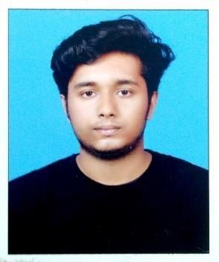 ABHILASH

Email: abhilash.392328@2freemail.com

O B J E C T I V E
Looking for a good career in professionally managed and competitive organization where the skills helps to put my efforts for the success of the organization and promotes my professional growth Hardworking. And Energetic Candidate With Over 9 Months Experience In SUPERVISING at Cochin Shipiyard. Willingness To Work Independently Or As Part Of a Team In a Growing Organization Where I Can Utilize My Knowledge And Skills And Can Acquire Growth.

E D U C A T I O N
- B.Tech – M G UNIVERSITY KOTTAYAM(2018)
B-Tech Mechanical Engineering Cochin Institute of science and technology Muvattupuzha.

- Plus Two(2014) Govt HSS, Kattoor.
Higher Secondary Examination, Kerala-INDIA

- SSLC(2012)
National Higher Secondary School
Kerala state board of examination, Kerala-INDIA

E X P E R I E N C E ’ S
S U P E RV I S O R | A D A M S C O N T R A C T O R S
Dates From 02/07/2018- To 30/04/2019
Working as a Supervisor in ADAMS CONTRACTORS.

K E Y S K I L L S
NDTLEVEL2asperASNT, SNTCI A1>VT, PT, MT, UT, RT, RTFI
PIPINGENGINEERING[ Fabrication, BOQ, Erection, Testing and commissioning]
QA/ QC–MECHANICAL( Oil and gas sector )
Awareness in codes and standards like ASME, APT, AWS, ASTM Reading WPS, PQR and can witness Welding Qualification Test Certified Course in Welding Inspector
Certified course in Health and Safety Environment.

O T H E R S T R E N G T H
Good qualitative apptitued along with good grasping power and eagerness to learn
Proficiency in communication skills
Experience in group activities and good coordination skills Linguistic ability : English, Malayalam - Read/Write/Speak
: Hindi - Read/Write
: Tamil – Speak

P E R S O N A L I N F O R M A T I O N

Gender : Male
Date of Birth : 24-05-1996
Blood Group : O +ve
Marital Status : Single
Father Name : Anandan V R
Mother Name : Beena Anandan
Nationality : Indian
Interests and Hobbies : Watching movies, Cooking,Travelling,
Listening Music, Football, Reading etc.

