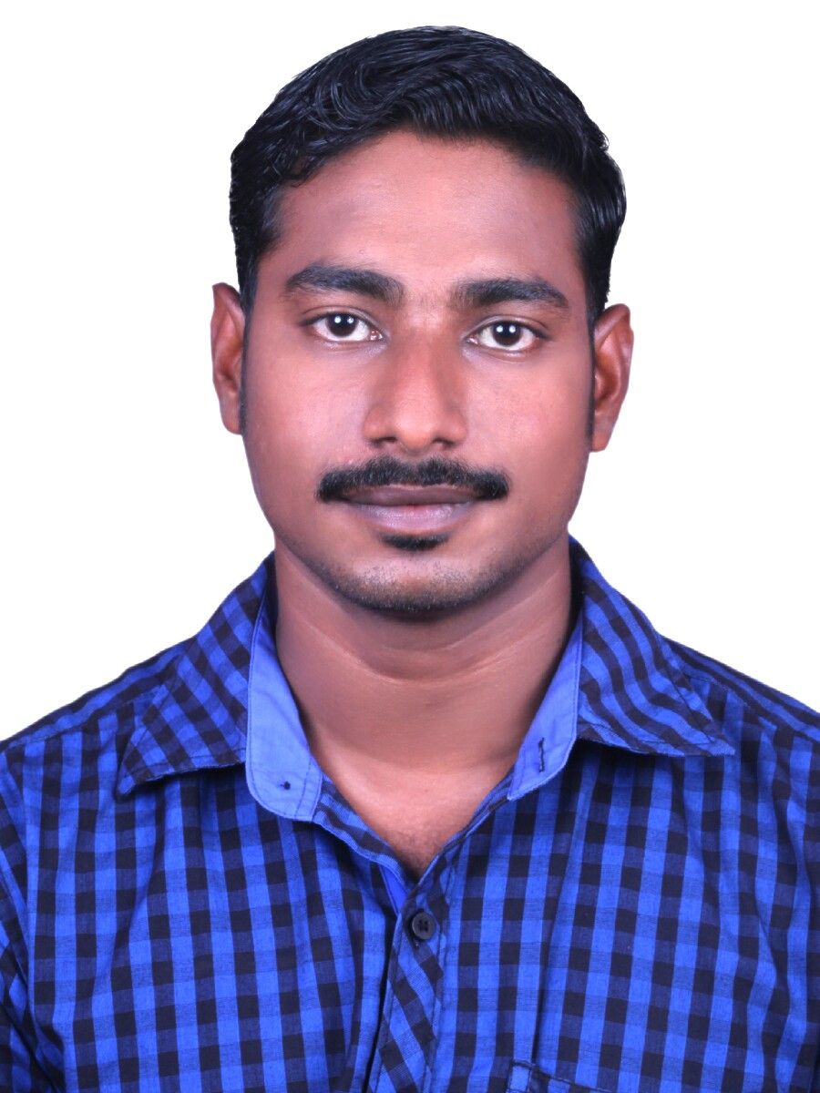

RAHUL
Rahul.392345@2freemail.com

EDUCATION  Diploma in  Mechanical Engineering  COMPUTER KNOWLEDGE  AUTO CADD  MS OFFICE  SOFTWARE KNOWLEDGE  WINDOWS PACKAGES  LANGUAGES  ENGLISH  MALAYALAM  HINDI  YEARS OF EXPERIENCE  4.6  EDUCATIONAL QUALIFICATION  Diploma: Mechanical  Year of  Passing :2014  Percentage : 80  University : kerala  College : S.N  Polytechnic  College  Kottiyam  Govt. I.T.I  Batch : Mechanical  Motor  Vehicle  Year of  Passing : 2010  Percentage : 75  Board : National  Trade  Certificate  College : Govt.ITI  Chandanathope  Higher Secondary  Batch :Computer  Science  Year of  Passing : 2008  Percentage : 72.5  Board : Kerala  Board  School : G.H.S.S  Bhoothakulam  SSLC  Year of  Passing : 2006  Percentage : 77  Board :Kerala  Board  School : G.H.S.S  Bhoothakulam  ADDITIONAL QUALIFICATIONS  ASNT LEVEL II Certificate in  - Visual Testing  - Radiographic Testing  - Ultrasonic Testing  - Magnetic Particle Testing  - Penetrant Testing  - Radiographic Film Interpretation | Experience Profile  - Have3 years6months experience in Autocad Drafting.  - Have 1 year Experience in Automoble Industry  Career Objective  To be a part of dedicated work force and achieve the targets laid down by the organization, using the best of my knowledge and skills.  Work Experience :1  Designation :- MECHANICAL DRAUGHTSMAN  Duration :- 01/11/2018 to Date  Project Involving  - MUSEUM OF THE FUTURE, DUBAI  Job Responsibilities  - Preparing Sectional and Elevation AutoCAD Drawings of Composite panels and Glass Sub Frames.  - Layout preparations of Panel Drawings.  - Preparing drawings for Template Cutting.  - Editing Drawings as per the Template Measurements.  - Preparing Laser Cutting Machine Programs.  - Preparation of schedules and sheet list.  - Coordinate with Designers and Department Engineers.  - Preparing daily Drawing Reports  Work Experience :2  Designation:- MECHANICAL DRAUGHTSMAN  Duration :- 2/06/2017 to 30/09/2018  Projects Involved  - CAYAN CATARA RESIDENTIAL AND SERVICED APARTMENT TOWERS, DUBAI  - AL JALILA FOUNDATION, DUBAI  - PROPOSED PRIVATE VILLA AT AL BARSHA SECOND SOUTH,DUBAI  Job Responsibilities  - Drafting of HVAC, Water distribution, Drainage, Rain water and Fire fighting.  - Preparing of schematic diagram for Piping and Ducting of Shop Drawings.  - Preparing cross sectional view in specified area of shop floor.  - Preparing Schematic,Duct routing and single line diagrams.  - Preparation of HVAC and FF shop floor drawing by including BOD, BOP and BOU.  - Sizing of duct supply Airflow, Return, Exhaust and Chilled water pipe.  - Coordinate with architects Senior Engineers and other department Engineers.  - Preparation of As-built drawings.  - Preparation of schedules and sheet list.  Work Experience :3  Designation :-TECHNICAL ASSISTANT  Duration :-10/02/2015to 02/03/2017  Projects Involved  - ZADCO OFFSHORE MAINTAINANCE JOB ON BOARD M/V ARADAH  Job Responsibilities  - Track all requisions for actual receipt of ordered items collate stores and consumable requisitionsfrom the Diving Department and Medic.  - Prepare the Daily Progress Report for the Approvelof DivingSupervisor,Captain and ZADCO Representative.  - PreparedAutocad Drawings of Boat landing including fenders, risers, ladders etc.  - Prepare Drawings of subsea pipelines with Clamps, replaced Anodes etc.  - Responsible for Crew changing, Time sheets, store  - Oganise and Maintain Project files Control and issue of all Project related Documentation.  - Ensure all Diving Equepments and other Machines Certifications.  Work Experience :3  Designation:-GENERAL TECHNECIAN  Duration:- 23/08/2010 to 01/09/2011  Job Responsibilities  - Examined vehicles to determine the extent of damage or malfunctions.  - Followed checklists to verify that all important parts were examined.  - Operated pneumatic tools and air compressors.  - Executed all phases of power system tear down and repair  - Repaired and replaced tires, shocks,structs and brakes.  - Contributed to repeat and referral business by using strong customer service and problem solving skills.  - Knowledge in wheel alignment and wheel balancing.  - Repaired and replaced wheel bearing,propeller shaft .  - Knowledge about common hand tools,such as sockets,ratchets,wrenches and torque wrench  Personal Details  Date of Birth :- 31/12/1990  Language Known :- English,Hindi,Malayalam,  Marital Status :- Single  Nationality :- Indian  Declaration  I do hereby declare that the above information is true to the best of my knowledge.  YOURS SINCERELY  RAHUL

