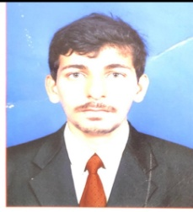

NAVEED

Naveed-392354@2freemail.com

OBJECTIVE:

A position that can give me an interesting working environment with responsibilities initializing my knowledge and offer scope for learning.

Strength:

To understand the responsibilities, do according to situation, dedication and willingness to work hard & strong commitment towards quality works.

PROFESSIONAL EXPERIENCE:
- FRESHER

EDUCATIONAL QUALIFICATION:

Bachelor of Commerce (B.com)
Karnataka University
Karnataka – India

Pre-University College (PUC)
Karnataka University
Karnaktaka

TECHNICAL SKILLS:

TALLY Accounting Software ERP9

MS-Office

Internet Fundamentals.

PERSONAL DETAILS:
Date of Birth : 09-APRIL-1994
Nationality: Indian
Marital status: Single

Visa Status: Visiting Visa

Languages: English, Hindi, Urdu, Kannada and Konkani

