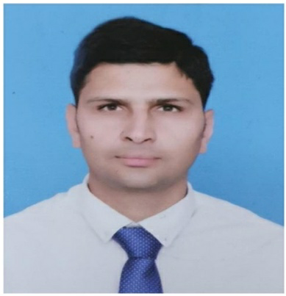
Chandan

Email: chandan.392360@2freemail.com

Summary
Dedicated, high energy law enforcement police officer with 12 years of progressive responsible and successful experience serving the public. Able to work in dangerous and stressful situations with meticulous attention to detail, using through intensive search techniques in investigative process. Skilled in collaborating with state and country law enforcement officials on investigative matters Intuitive, persuasive, compassionate officer willing to go above and beyond call of duty to ensure public safety, received numerous commendations from state officials. Able to interact effectively at various social levels and across diverse cultures.

Skill Highlights:
- Cyber Crime (Information Technology) cases investigation expert
- Tracing culprits by mobile locations and through informers
- Extortion/Robbery/Murder/ heinous cases investigation expert.
- Catch Hardcore criminal’s red handed.
- Familiar with search and seizure laws.
- Community relations
- Firearms and weapons expert
- Law knowledge
- Extensive gang knowledge
- Drug laws enforcement
- Undercover operations
- Crime prevention
- Radar speed measurement

Professional History:
Crime Investigation Agency (CIA) in Haryana Police June 2008 to December 2011
Security & Intelligence Services Officer & duty management July 2012 to December 2015
Reader to DSP Palwal January 2016 to January 2018
Cyber Crime Haryana, India (Special Officer) February 2018 to date

Job Responsibilities:

- Fingerprint analyze expert at crime spots.
- Respond quickly to dispatch and take appropriate action at crime and disaster scenes.
- Assist with cover and undercover investigations to uncover ongoing crimes and crime in progress.
- Prepare cases for trial, appear and testify in court as a witness.
- Patrol designated districts in patrol cars and Motorcycles.
- Mediate domestic- related disturbances and protect victims from harm.
- Search vehicles, buildings, homes and property for evidence and stolen property.
- Directly control the crowd at parades funerals processions and at sports events.
- Conduct high speed vehicles chases in serious and emergency situations.
- Organize and record facts to prepare incident reports.
- Gathered preliminary investigation information as a first responder to crime scenes.
- Monitored and investigated suspicious culprits and situations and unusual activities.
- Directed traffic during emergency and congested situations.
- Inspect suspects on field sobriety tests and used portable equipment to perform tests.
- Liaised with school counselors and administrators regarding juvenile offenders.
- Wrote reports on arrests made, activities performed, and usual incidents observed.

Achievements in Police department:

- Was awarded by Sh. Laik Ram Dabbas IPS, Additional Director General of Police Haryana as best Fingerprint expert in 2012 according OB no. 88/12 date 25-05-12
- Was awarded (on recovery of 230 kg. N.D.P.S. Drugs and arresting the accused) by Inspector General of Police South Range Rewari, Haryana according order no. 4745 date 06-06-12, OB no. 123/12.
- Was awarded by Sh. Laik Ram Dabbas IPS, Additional Director General of Police SCRB Haryana as maintenance law and order, Safety, Security management and duty management according OB no. 34/12 date 6-12-12, OB no. 289/11 date 31-12-11
- Was awarded by Inspector Director General of Police SCRB Haryana as maintenance law and order, Security management according OB no. 80/12 date 25-05-12. Total 25 times rewarded by IPS (Indian Police Service) officers for my best performance in department.

Academic Credentials

- Finger Print expert Course in Finger Print Bureau State Crime Record Bureau Haryana, Madhuban (India) in 2009.
- M.B.A. in marketing management from Arunachal university in 2017.
- B.A. from Delhi university in 2011.
- Computer knowledge (Word & Excel).

Personal Details

Date of Birth 30th March 1987
Marital status Married
Nationality Indian
Language known English, Hindi and Punjabi

