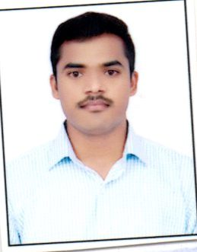
ANIL
Email: anil.392396@2freemail.com

Career Objective:

To gain experience in the field to utilize my skills, in order to increase productivity of organization and individual growth. I can adjust to any working environment as well as prove to the one of the best.

Academic Qualification:

- MBA (FINANCE) POST GRADUATION FROM ACHARYA NAGARJUNA UNIVERSITY 2018
- B-COM(CA) APPEARED CHAITANYA DEGREE COLLEGE FROM AUTONOMOUS HANAMAKONDA 2016
- INTERMEDIATE FROM SRIVIKAS JR. COLLAGE, WARANGAL 2011
- S.S.C PASSED FROM SCHOOL SECONDARY CERTIFICATE, ANDHRA PRADESH IN MARCH 2009

PROFESSIONAL QUALIFICATIONS:

- PG DIPLOMA IN AVIATION, HOSPITALITY, TRAVEL AND CUSTOMER SERVICE
- ADVANCED DIPLOMA COURSE IN PRINCIPLES AND PRACTICING OF TOURISM
SKILLS:
- Excellent customer service skills
- Strong written and spoken communication skills
- A polite and professional approach
- The ability to solve problems
- The ability to deal tactfully with upset or angry passengers
EXPERIENCE:

RGI AIRPORT (HYDERABAD)

1) I have worked in spice jet as Security executive for 10 months

2) I have worked in Air India Sats as customer service agent for 18 months

EXPERIENCE SUMMARY:
Our day-to-day duties might include:
- Dealing with passenger enquiries about flight departures and arrivals
- Checking in passengers and giving seat numbers
- Providing boarding passes and luggage labels
- Passengers about luggage restrictions
- Weighing baggage and collecting any excess weight charges
- Taking care of people with special needs, and unaccompanied children
- Calming and reassuring nervous passengers
- Responsible for working on the phone and in person to provide information about travel plans for customers.
- This could involve giving the customer information about arrival and departure times, reserving tickets with a particular airline, and a wide variety of other topics.
- Customer service reps are responsible for greeting passengers, guiding them to the proper terminal.
- Explaining airport regulations, and asking for volunteers to take a later flight when one has been overbooked.

AREAS OF EXPERTISE:

_MS OFFICE MS WORD _RAMP -CARGO _CHECK IN COUNTERS
_ SURVEILLANCE _FLIGHT OPERATIONS

AMBITIONS:

To work in a challenging environment and constantly update, adapt to changing Technologies and contribute effectively to the development of the organization.

Personal Details:
.
DOB : 25/06/1994
Gender : Male
Marital Status : Single
Language known : English, Hindi & Telugu
Blood group : O+ve
Hobbies : Playing Cricket & Listing Music

Declaration:

