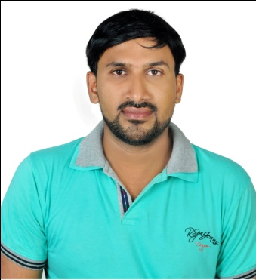 muhammedali.

Email: mohammedali.392402@2freemail.com

Objectives
To join the engineering wing of a reputed and progressive organization and achieve a name in it through hard,dedicated and sincere efforts, to make a valuable contribution for the wholesome growth of the organization and my personality.

Summary of qualifications

Diploma in DGPS & Total station : 2015, V institute of Advanced Studies ,kollam kerala
Draughtsman Civil : 2003, NCVT(National Council for Vocational Training)
Plus Two : 2001, Board of Educational ,kerala
Secondary School (SSLC) : 1999, Board of Educational, Kerala.
Computer Skills : Microsoft Word and Microsoft Excel.
Total station Software : LisCAD, Auto Plotter, Road Estimator
2D Software : Excellent proficiency in AutoCAD 2000-2010.
Presentation Software : Ms office.

professional experience

- Worked with M/s. ACROSS THE FUTURE IN RIYADH,SAUDI ARABIA., in the capacities of Surveyor with Draughtsmen From February 2008 to June 2015.
- Worked with M/s:Gopalan Enterprices Architectors,Builders & Promoters Pvt. Ltd.,Head Office-Richmen Road,No:5,Banglore,India, in the capacities of Civil Draughtsman(Altreration Dprtmnt) From October. 2006 – November. 2007.
- Worked with M/s: Crescent Builders & Engineering Developers, Kerala, India, in the. capacities of Site Engineer From September. 2004 – August. 2006

WORK EXPERIENCE WITH Al-ACROSS THE FUTURE SHOPPING MALL (AL EHSA MALL HOFUF)

From February 2008 to June 2015. i worked for a Shopping mall (Structural leveling ,Landscaping and Road,Parking Design levels, Across the future Riyadh. Al-ehsa mall is one of the biggest multi-shopping mall in hofuf. Working with company, i gained lot of experience in Design levels with surveying and Drawing work, also got experienced in communicating with people from various nationality and region.

Responsibilities Held as a surveyor

- Preparation of profile drawing and coordinates (using in LisCAD)
- Assisting the estimation Engineer to taking quantities from the tender drawings.
- Preparation of Road design drawing by Auto CAD with stake out.
- Preparation of design levels using level isrtument, Dumpy level
- Preparation of cut and fill volume (stakeout)
- Preparation of work progress schedule on a dialy basis.

Responsibilities Held as a draughtsman

- Preparation of drawings for clients/Consultants approval
- Preparation of material submittal.
- Supervising and Co-Ordination with site
- Preparation and Maintaining drawing register
- Preparation of As Built drawings after completion of the project
- Preparation of work progress schedule on a dialy basis.

WORK EXPERIENCE WITH M/S: Gopal enterprices pvt.ltd., BANGLORE,INDIA.

From October 2006 to November 2007, i was working for a named Gopal Enterprices Architector’s,Builder’s & Promoter’s Pvt.Ltd.,an ISO 9001 company. It is one of the top most reputed firm in Banglore. I was posted here as a Civil Draughtsman.

Projects involved

Gopalan Jewels project,Kanakapor Road,Banglore.(Construction Of Three Towers Each Tower Consists 21 levels.)

Responsibilities HELD:-
- Column alignments and column set out
- Responsibilties in road direction and parking levels .
- To produce detailed civil drawings and construction shop drawings.
- To co-ordinate with various departments, structural departments for co-ordination drawings and levels as per the instructor .

PERSONAL EBILITIES
- Ability to work in teams as well as individual
- Ability to negotiate and motivate
- Skilled in communication
- Good organizer with knowledge of efficient planning and time management

PERSIONAL INFORMATION

Profession : SURVEYOR –OR- DRAUGHTSMEN
Full Name : Muhammedali
Date of Birth : 8th. june, 1983
Nationality : Indian
Marital Status : Married
Languages Known : English,Arabic,Urdu

