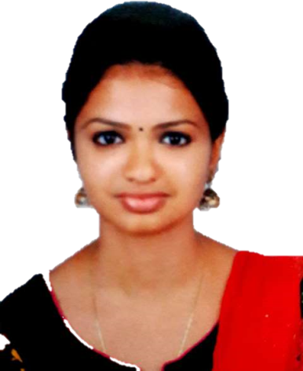

**Objectives:**

Intend to build a career in leading corporate of hi-tech environment with committed, professionaland dedicated people, which will help me to explore myself more and realize my potential strengths. The interest to lean and grown make me willing and eager to work as a key player in challenging environments with diverse opportunities for creativity.

**Personal Information**

**Civil Engineer**

**Krishna**

**Education:**

⮚ 2015-2017 Masters in structural engineering  
APJ Abdul Kalam University – Kerala  
Passing with overall grade of 83%

⮚ 2011-2015 Bachelor in Civil Engineering  
Calicut University– Kerala  
Passing with overall grade of74%

⮚ 2009-2011 Higher Secondary School  
Kerala Board of Public Examinations– Kerala  
Passing with overall grade of89%

**Experience:**

⮚ 2018-Present Professor Assistant

⮚ 2017- 2018 Structural Engineer

**E-mail:** [**Krishna.392410@2freemail.com**](mailto:Krishna.392410@2freemail.com)

**Nationality:Indian**

**Date of Birth:26 – 10 – 1992**

**Status: Married**

**Languages: English, Hindi &Malayalam**

**Computer Proficiency:**

Auto CAD 2D &3D  
STAAD Pro.  
SAP 2000  
E- TABS  
Primavera  
Microsoft office

**Targeted Market**

**Soft Skills:**

* Ability to work within teams and at leadership roles.
* Capability to perform efficiently under pressure.
* Self-motivated and task oriented.
* High adaptability and time management.

**Structural Engineering   
and Design  
  
Quantity Estimation   
and Tenders**

**Reading  
Music   
Witting Diaries   
Watching Documentaries**

**Hobbies**

**Declaration:**

I KRISHNA do hereby declare that the entropy acknowledged is precise to the best of my cognition and impression; I have not recouped any information that might reasonably be calculated to adversely impact my suitability for employment.