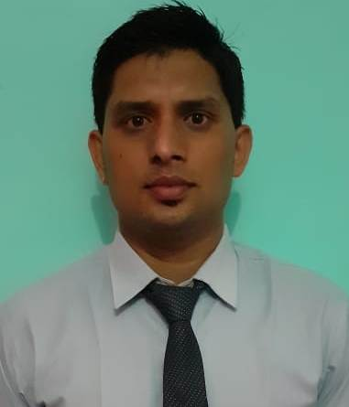MANOJ

About Me

Manoj-392411@2freemail.com

August 15, 1995
2+Years experience

PROFILE
High energy Civil Engineer who skillfully manages the demands of the building construction and inspection process. Interested to work in good environment. Having excellent communication skills and seeking to expand talents in Construction Project.

Education

Bachelor ofTechnology (B.TECH)
B.TECH (CIVIL ENGINEERING WITH HONOURS) :Graduated, July 2016
Graphic era hill university, Dehradun: Civil:Division 1
Engineering
Senior secondary (10+2)
Sri Guru Teg Bahadur Sr.Sec School : 2012
CBSE Board :Division 1
New Delhi, Delhi
Higher secondary (10)
Universal Convent Sr. Sec School:2010
CBSE Board New Delhi, Delhi:Division 1

Professional Certification

- Certificate on 'Ground Improvement Technique in hilly regions' from IIT Roorkee
- Certificate from Microsoft.

Career Highlights

- Acted as Lead Design Engineer on multiple signing and Construction.
- Worked on a Project entitled 'SOIL RETENTION USING GEO CELL'.
- Training from PWD (public work department) Haldwani, India under the supervision of
A.E (Assistant Engineer).
- Well Understanding of 'Interlocking tiles' on pedestal, 'KC Drain (kerb cement drain)'
And working of 'Hot mix plant'.

Skills

- Excellent communication skills
- Microsoft Excel, Project
- Storm water management
- Geometric
Dimensioning
- Commercial and residential planning
- Design
- Superior time management

Work Experience

JULY 2018-PRESENT
- PROFESSOR, CIVIL ENGINEERING DEPARTMENT | UTTRAKHAND, INDIA.

SEPTEMBER 2016-JULY 2018
- SITEENGINEER INDIA -UTTRAKHAND|

- Visited project sites during construction to monitor progress and consult with
Contractors and on-site engineers.
- Inspected project sites to monitor progress and adherence to design specifications,
Safety protocols and state sanitation standards.
- Advised managerial staff about design, construction and program modifications.
- Reviewed calculations and analytical data to maintain accuracy of the technical
Reports.
- Estimated quantities and cost of materials, equipment and labor to determine projectFeasibility.
Computer Proficiency

- AutoCAD 2D-3D software
- AutoCAD Architecture software
- STAAD.Pro software
- Building Design software
- Estimator 2.0
- Word
- Power Point
- Ms-Picture manager

Achievements
- Won 'champion award' for two times in games at the school level'
- Received first prize in 'Role Play' at the college level.
- Received first prize in 'Khoj' surveying at the college level.
- Received 2nd prize in 'Desktop configuration' at Amarapali institute, Haldwani.
- Received certificate of Appreciation from 'caring soul’s foundation' a NGO.
- Player at the Distt level in 'shot Put'.
- Player at the Distt level in 'sprint races'.
- Selected for 'Achiever's Meet'-2014 at college.

Languages

- Hindi
- English
Personal
Birthday: August 15, 1995
Gender: Male
Marital Status: Single
Nationality: Indian
Visa Status: Visit Visa

Declaration
I, Manoj, hereby declare that the information contained herein is true and correct to the best of my knowledge and belief.

DATE Manoj

