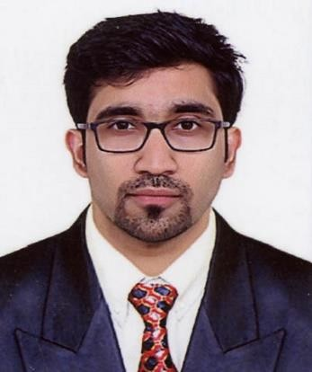
Vijin

vijin-392414@2freemail.com

To pursue my career with integrity and dedication in a field where I can effectively utilize my strength to achieve proficiency and higher degree of satisfaction.
CAREER OBJECTIVE

MEDIZ INTERNATIONAL LLC July 2018 — Present
WORK EXPERIENCE

Mediz international is a health & beauty product supplier in United Arab Emirates. Main clients are Lulu hypermarkets, Adnoc, pharmaceuticals, KM trading etc.

Sales executive (Hypermarkets & Pharmaceuticals)

Roles and responsibilities
- Maintain good relationship with clients.
- Direct meeting with buyers to take orders.
- Make a route plan and visit the outlets regularly.
- Maintain a good relationship with the outlet supervisors and section in-charges.
- Delivering the products to the outlets according to LPO.
- Make sure the products are available in the markets.
- Follow up with merchandisers regarding displays and availability of stocks in the outlets.
- Making sure deliveries are done without fail.
- Collection of cheque from customers.

AL JABER GALLERY March 2015 - June 2018
Inside Sales Representative

Roles and responsibilities

- Greeting the customers
- Assisting shoppers to find the goods and products they are looking for.
- Be involved in stock control and management.
- Being responsible for processing cash and card payments.
- Stocking shelves with merchandise.
- Answering queries from customers.
- Reporting discrepancies, damages, repair and problems to the supervisor.
- Giving advice and guidance on product selection to customers.

FUTURA AUTOMATION PVT LTD Sept 2013 to Sept 2014

Futura Automation is a photocopier machine dealer for RICOH brand. Roles and responsibilities.
- Coordination with marketing and sales team.
- Meeting and acquisition of new corporate clients.
- After sales support to clients.
- Coordination and manpower allocation for maintenance activities.

EBEN TELECOM PVT.LTD Dec 2012 to Aug 2013.

Roles and responsibilities.
- Meeting and acquisition of new corporate clients.
- Give suggestion about the plans and benefits to the employees and corporation.
- After sales support to clients.
- Continual interaction with the marketing and presales team to get the information about new clients.
- Documentation of the sales details as per the company procedure.
- Weekly and monthly progress and sales report presentation to higher management.

- MBA (Marketing& HR), Srinivas Institute of Management Science, Mangalore, India (2010-2012)
ACADEMIC CREDENTIALS
- Bachelor of Business Management, SNR sons college, Coimbatore, India (2006-2009)

- A self-motivated person, I strongly believe in being true to myself.
SKILLS
- Self-motivated and high level ofcommitment.
- Good analytical, communication and organizationskills.
- Possess leadership quality and team spirit and adaptability to new environments.
- Broad-minded, confident andadaptable.

COMPUTER SKILLS
COMPUTER SKILLS
- MS Office, Tally, AutoCAD with 3D max

