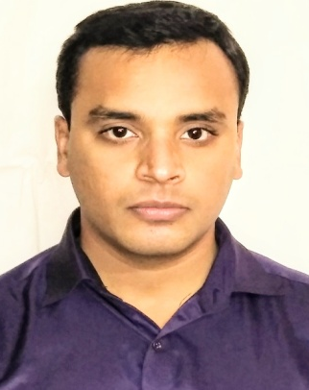
CURRICULUM VITAE
PRITHWIS
HOSPITALITY, SALES & FITNESS
D.O.B.: 27.08.1988
Nationality: Indian
Email: Prithwis-392415@2freemail.com

OBJECTIVE:

Dedicated fitness instructor and personal trainer embodying a serious commitment to personal fitness through customized fitness programs. Adept at helping individuals with varying abilities achieve their fitness goals in a comfortable supportive environment. Specialize in promoting fitness programs targeted at all age groups.

WORK EXPERIENCE:
6 Years of Professional Experience
Gym & Spa supervisor -- The Park Hotel Kolkata, India (Augist 2017 – Present)

Duties & Responsibilities
- Assessed the fitness abilities of each member and made exercise recommendations.
- Developed weight loss and fitness programs available to all gym members.
- Maintained weight-lifting treadmills and other gym equipment.
- Responded to questions in a courteous professional manner.
- Developed and coordinated injury rehabilitation programs.
- Provided circuit training, spinning, stretching and weight training (uses of kinesis and power plate).
- Ensured the safety of all gym members.
Key Achievements
- Archive a good position as personal trainer to all members and clients.
- Holding a good sales scale for the non peak months.

Fitness instructor -- The Kenilworth Hotel Kolkata, India (May 2016 - July 2017)

Duties & Responsibilities
- Initiated fitness activities and interacted with employees to encourage participation
- Coordinated with HR to determine objectives related to employee health and fitness
- Developed health awareness campaigns
- Developed individual fitness programs for interested employees.
- Provided one-on-one training while working flexible hours.

Key Achievements
- Got promoted from supervisor to senior supervisor.
Fitness consultant and Receptionist --The Gold's Gym Kolkata, India (August 2013- April 2016)
Duties & Responsibilities
- Developed individualized instruction plans including cardio and weight training.
- Organized equipments, tested microphones, and selected music prior to each session.
- Helped clients of all ages in improving fitness levels and overall wellbeing.
- Worked on membership selling.
Key Achievements
- Got promoted from receptionist to general fitness trainer

SPECIALIZED SKILLS
- Personal training classes
- Duty & team Management
- Continuous sales Process Improvement
- Staff and Customer Relations
- Training and Leadership

OTHER ACHIEVEMENTS
- Awarded from Microsoft as trainee on software demo and sales at 2013

OTHER INTERESTS
- Interior designing
- Body building
- Drawing
- Photography
- Travelling
RELEVANT CERTIFICATIONS:
- CPR and First-aid certification from American Red Cross
- Personal training certification from Gold’s Gym India
EDUCATIONAL BACKGROUND:

- B.com from Calcutta University
- Indian art certification from RMIC Kolkata
- Secondary education from West Bengal Board of Secondary Education

RELEVANT QUALIFICATIONS:
- English: Fluent in speaking, reading and writing
- Hindi: Fluent in speaking
- Bengali: Fluent in speaking, reading and writing

PERSONAL INFORMATION:
Full Name: Prithwis
Nationality: Indian
Marital Status: Married
Date of Birth: August 27, 1988
Place of Birth: Kolkata, West Bengal, India

