CURRICULUM VITAE
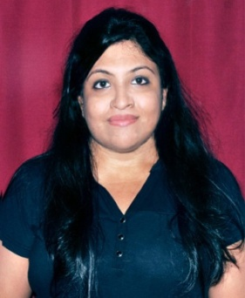

Debalina

debalina.392433@2freemail.com

Creative writing/ Medical writing/ SEO content writing
An ambitious and technically oriented candidate, having good communication and wide range of writing and proof reading skills

SUMMARY:
- Researching and sorting information, verifying the accuracy and compiling them in order to prepare source data for producing informative contents
- Have rich experience in writing SEO friendly blogs, articles, technical contents, press releases, web contents, e-commerce testimonials, classifieds, product reviews and descriptions, business listings, celebrity biographiesand so on
CORE SKILLS:
- Using exactinformation gathered from the respective sources
- Reviewing the write-ups for errors and incompatibilities, checking the relevance of the contents
- Ability to come up with SEO friendly, non-plagiarized contents
- Ability to meet the deadline without compromising with the quality of the contents.
- Rich experience of working with Microsoft Office
- Researching a lot before crafting out well-formatted contents
- Making use of high-end software to check the readability and the originality of the contents.

EXPERIENCE:
- Currently working as the content head (November 2017- till date)
- Worked as a content writer ( September 2016- November 2017)
- Worked as a content writer (January 2016- August 2016)

EDUCATION:
- PGDM in Journalism from Bhavan’s College of Communication and Management (September 2015)
- Bachelor of arts (English horns) from university of Calcutta (2014)
PERSONAL INFORMATION:
- Nationality: Indian
- Marital Status: Married
- Date of Birth: September 25, 1993

Debalina

