CURRICULUM VITAE
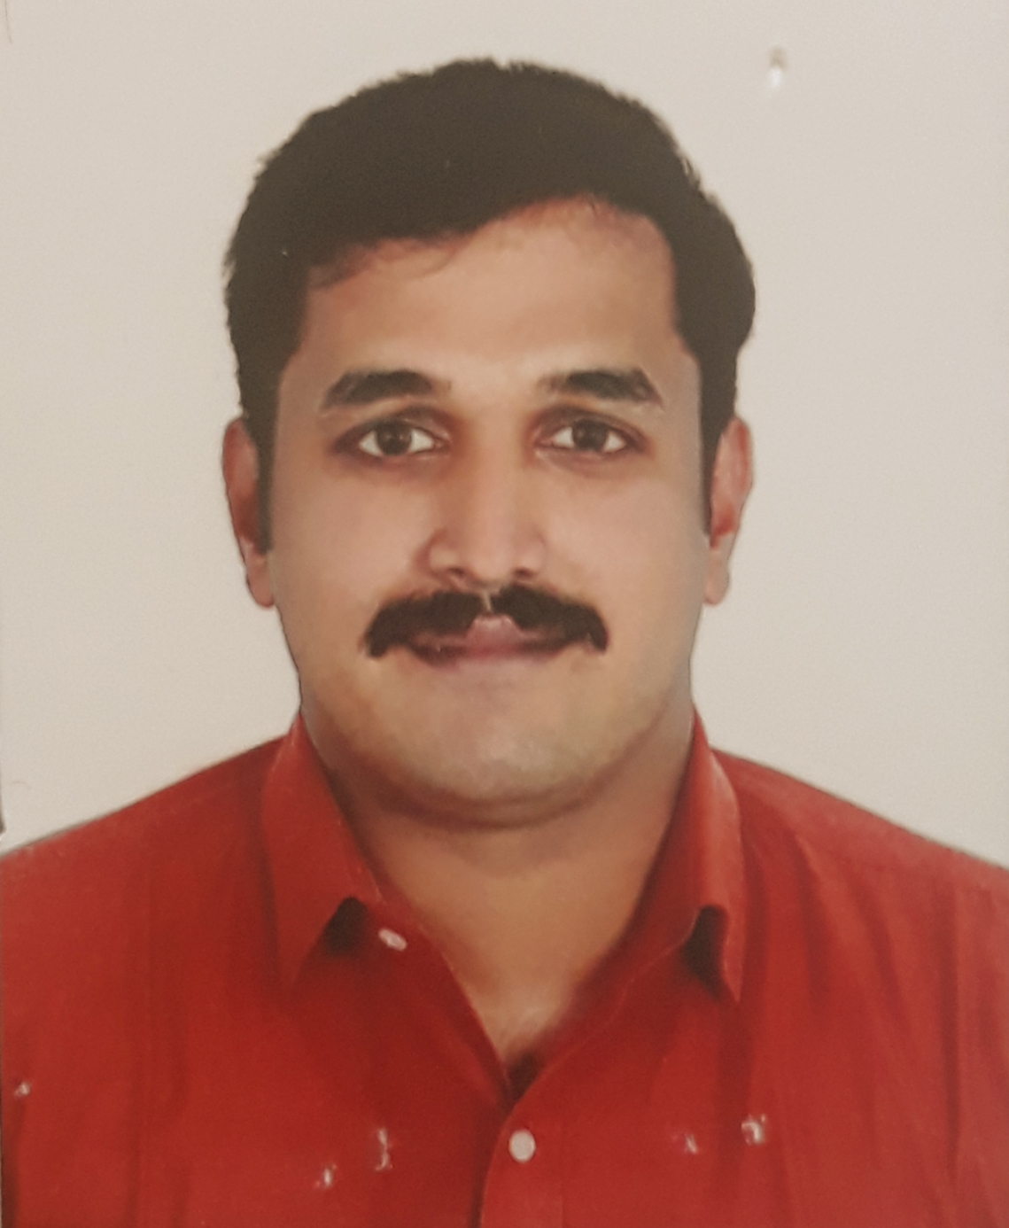

ANANDHU

Email: anandhu.392499@2freemail.com

CAREER OBJECTIVE
To seek an employment in a prestigious and reputable organization where I could have a clear path and professional growth and at the same time render my best service to the company. My prime motivation is to develop my accumulative experience and abilities and serve the company to fullest extent.

TECHNICAL QUALITIES
- Good knowledge of General& Civil Foreman.
- Good knowledge of up-to-date site procedure.
- Team leader skills especially good knowledge of language proficiency.
- Well-known with civil drawings.
- Oversaw work crews and ensured on time execution and under budget construction projects by appropriately allocating resources to multiple, concurrent jobs. High customer satisfaction consistently reported.
- Calculated needs and procured tools and supplies for all construction works.
- Coordinated multiple work crews and successful planned and communicated schedule on an day-to-day basis.
- Initiated implementation of company wide financial accounting and reporting software system.
- Both practical as well as theoretical knowledge of Different mechanical equipment’s.
- Working more efficiently and productively so that maximum output comes.
- Planning & scheduling assignments to achieve pre-set goals within time parameters. Formulating long term/short term strategic plans to enhance operations

PERSONAL QUALITIES
- Professionals for achieving the deadlines for the execution of work
- Excellent Communication, listening and motivating skills.
- Ability to learn quickly is my forte that has helped me successfully manage various jobs given.
COMPUTER PROFICIENCY
- Expert in Auto Cad 2017, 2015, 2010 &2007 versions
- Well versed in Windows-98, Windows XP and Windows 7.
- Proficiency in entire MS-Office
- Good understanding of Internet tools
EMPLOYERS
Designation: Quality Controller &Civil Foreman.
Company Profile: Civil construction works.
Experience: 6 months
Responsibilities
- Executes the specific inspections on materials, equipment and construction / installation activities on site.
- Issue the relevant Quality records and when necessary write and sent to Quality control supervisor non-conformances reports.
- Oversaw work crews and ensured on time execution and under budget construction projects by appropriately allocating resources to multiple, concurrent jobs. High customer satisfaction consistently reported.
- Check the documents certifying the tests, controls and inspirations carried out.
- Calculated needs and procured tools and supplies for all construction works.
- Coordinated multiple work crews and successful planned and communicated schedule on an day-to-day basis.
- Initiated implementation of company wide financial accounting and reporting software system.
- Both practical as well as theoretical knowledge of Different mechanical equipment’s.
- Working more efficiently and productively so that maximum output comes.
- Planning & scheduling assignments to achieve pre-set goals within time parameters. Formulating long term/short term strategic plans to enhance operations

- QASR AL HAMRA MARBLES & BUILDING MATERIALS
SHARJAH, UAE
Designation: General Forman & Water jet Designer
Company Profile: International Omani Marble Dealer
Experience: 2 Year

Responsibilities
- Responsible for operation, loading and unloading material and parts, proving programs, operating controls, setting offsets, deburring and inspection of quality parts for conformance to requirements.
- Studies and interprets drawings, manuals, specifications or sample parts to determine dimensions and tolerances of finished products, sequence of operations and set up requirements.
- Ensure productions rates are met or exceeded.
- Detects equipment malfunctions or out of tolerance machining and adjusts machine, within capabilities, controls or control media as required to insure quality of productions. Reports all machine malfunctions to Management.
- Communicates with management, production control, quality and other shop personnel for assignments and to resolve machining or quality issues.
- Responsible for keeping equipment and work area clean and orderly and perform basic preventative maintenance functions on equipment.
- Suggest and implement improvements.
- Communicates all production related items to next shift Water Jet operator or shift supervisors.
- Completes all required safety procedures prior to and during operations.
- May perform other duties as assigned by management.
- Conform to the company’s culture of quality, service and continuous improvement, while taking personal responsibility for your own actions and treating fellow employees, customers and vendors respectfully and ethically

- ADITYARAM GROUP
Designation: MEP DRAFTSMAN
Company Profile: Builders and developers
Experience: 1 Year
Responsibilities:
- To create technical drawings based on given specifications and calculations.
- Work with professionals in their field, such as scientists, architects and engineers, who provide the product or structure's details.
- The draftsman incorporates these specifications into drawings and plans that may be used in the manufacture, maintenance or repair of the product or structure.
- Use CADD systems to create, save and view their drawings and plans. Depending on the project, draftsmen may need to use more traditional drafting methods, such as drafting pencils and T-squares, to create their drawings. Besides creating drawings, other duties of a draftsman can include calculating structural strength, assessing building capacity limits and estimating construction costs.
- SQUARE ARC BUILDERS AND CONSTRUCTIONS
Designation: Electrical Site Supervisor (Maintenance)
Company Profile: Construction of building and other public works
Experience: 1 Year
Responsibilities
- Handling of electrical load as per requirement.
- Analysis of electrical consumption & consumed demand.
- Daily maintain the power consumption report.
- Weekly preparing the Formats of Preventive Maintenance

- SHRIRAM TRANSPORT FINANCE COMPANY LTD.
Designation: Senior Product Executive
Company Profile: Vehicle Finance, Insurance and asset backed loans
Experience: 1 Year
Responsibilities:
- Responsible for assigned sales targets (monthly, quarterly and annually).
- Goals set for centers month on month, maintaining relationship with target customers, customer service, ensuring high rate of return on investment, sales support and sales.
- Follow up for payment.
- Maintain good relation with client.

- Chettinad Cement
Designation: Sales Executive
Company Profile: Manufacturing cement,
Responsibilities
- Responsible for assigned sales targets (monthly, quarterly and annually).
- Goals set for centers month on month, maintaining relationship with target customers, customer service, ensuring high rate of return on investment, sales support and sales.
- Operating Internet, updating all records and documents (Hard copy as well as Soft copy), Purchasing and maintaining stocks, Data Entry, Updating accounts, Compiling MIS reports, Networking with different stake Holders and organization.
- Proper execution of order and dispatch it on time.
- Follow up for payment.
- Maintain good relation with client.

BACKGROUND SYNOPSIS

Successfully completed Diploma in M E P Designing from CADD Institute.

ACADEMIC QUALIFICATION

- B A HISTORY:
- Passed in 2016 from Madhurai Kamaraj University.
- DIPLOMA IN Revit MEP:
- Passed in 2016 from CADD CENTRE.
- B. Tech Degree Electrical & Electronics Engineering
• Completed in 2014from Kerala University.
- Intermediate:
- Passed in ‘2010’ – from S V M M H S S, Vendar, Kottarakara
- Matriculation:
- Passed in ’2008’ – from S V M M H S S, Vendar, Kottarakara

EXTRA CURRICULAR ACTIVITIES
- NCC
- SPORTS
- ARTS

KEY SKILLS AND ATTRIBUTES

- Technically proficient in Auto CADD, MS Word, Excel, PowerPoint.
- Good communication and interpersonal skills.
- Committed team player with flexible approach towards work.
- Aggressive target-oriented personality and very committed towards the assignment given to me.
- Creative, innovative, hardworking, Enthusiastic, punctual and ‘Honest’.
- Matured enough to handle sensitive information in a professional way.

HOBBIES
- FOOTBALL
- VOLLYBALL
- CRICKET

AREA OF INTEREST
- Civil & General foreman
- Drafts man & Design Engineer
- Marketing
- Human Resources Management
- CNC Programing
- CNC Operation

PERSONAL DETAILS

Date of Birth : 26thNov, 1991
Sex : Male.
Marital Status : Married
Nationality : Indian.
Religion : Hindu

LANGUAGES KNOWN

- ENGLISH
- HINDI
- MALAYALAM
- TAMIL

