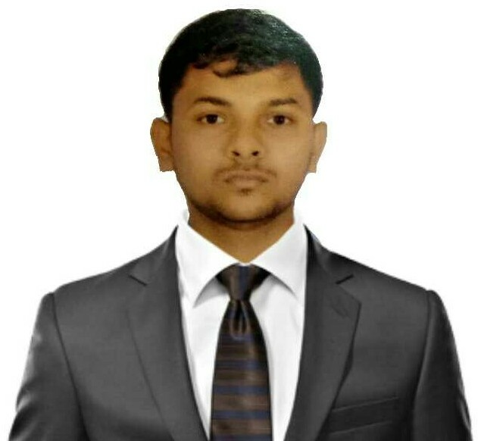
CURRICULUM VITAE

AFSAR
afsar-392473@2freemail.com

BACHELOR OF CIVIL ENGINEERING

OBJECTIVE:
Seeking for a challenging position as a Civil Engineer, where I can use my planning, designing and overseeing skills in construction and help grow the company to achieve its goal.

EDUCATIONaL QUALIFICATIONS:
Qualification | Institution | Name of the  Board | Year of  Passing | Percentage
BE in Civil Engineering. | Sri Sairam Engineering College West Tambaram  Chennai | Anna University | 2015-19 | 68%
HSC | JRK Matric.Hr.Sec  School  Kattankulathur. | State Board | 2014-15 | 83%
SSLC | JRK Matric.Hr.Sec.  School Kattankulathur. | State Board | 2012-13 | 93%

ADDITIONAL QUALIFICATION:
Qualification | Institution | Year of  Passing
Quantity Surveying | Aladdin Academy  Quantity Surveying Institute | 2019

SOFTWARE PROFICIENCY
- MS-Office (Excel, Word & PowerPoint)
- AutoCAD Civil
- Staad Pro
- Revit Architecture

Area OF INTEREST
- Construction Planning
- Estimation Engineer
- Quantity Survey

ENGINEERING PROJECT

DESIGN OF PRIVATE HOSTEL BUILDING
- Period: 2019
- Duration: 6 Months
- Description: The project deals with the Planning Analysing, Designing and Construction of a Hostel Building.
HYBRID FIBRE REINFORCED CONCRETE WITH PARTIAL REPLACEMENT OF FINE AGGREGATE
- Period: 2019
- Duration: 6 Months
- Description:
- The project deals with the partial replacement of fine aggregate with two different fibers namely polypropylene of 1.5% and glass of 0.5%,1%and 1.5% were replaced with weight of cement.
- The compressive Tensile and Flexural strength of concrete increases due to better load transfer with in the fibers.
- The usage of fiber decreases the porosity and deflection of the concrete member.

INPLANT TRAINING
- Company: Brahma Developers
- Place: Tuticorin
- Duration: 1 Month
- Learned: Knowledge about the multi-storey building construction

INSUSTRIAL EXPOSURE
- Visited Akshaya Homes Project in-Thuraipakkam
- Visited Dakshina Chitra Muttukadu-Chennai
- Visited Ready Mix Concrete plant –Thiruneerumalai
- Visited poondy reservoir- poondy
- Visited Council of Scientific and Industrial Research centre (CSIR)

WORKSHOP AND SYMPOSIUMS
- MS-Office Tools Participated in Illuminate 2017- A series of Pre-Eureka Business model workshops organized by The Entrepreneurship cell IIT Bombay hosted by Sri Sairam Engineering College
- Participated in the 3 day Entrepreneurship Awareness Camp organized by IEDC (Innovation and entrepreneurship Development Centre) Sri Sairam Engineering College.
- Organizer of National level technical civil engineering symposium on 2018 a Sri Sairam Engineering College

EXTRA & CO CURRICULAR ACTIVITIES
- Member of Research & Development club
- Member of Indian society of technical education(ISTC)
- Attended workshop on RCC DETAILING at cadd centre
- Participated in National level technical symposium in model making at Meenakshi engineering college.

STRENGTH
- Flexibility and Adaptability
- Learning ability: Quick learner
- Excellent Problem solving abilities
- Computer Skills
- Self-confident and self-driven
- Positive thinking

Personal DETAILS:
- Date of Birth : 31-July-1997
- Gender : Male
- Nationality : Indian
- Religion : Muslim
- Marital Status : Unmarried
- Languages Known : Tamil, English, and Arabic (Read)

