Tajinder
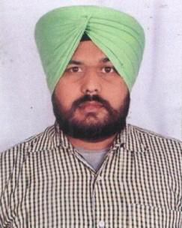

Tajinder-392476@2freemail.com

CAREER OBJECTIVE

To obtain a responsible and challenging position within your company that will allow me to learn new technologies and skills while utilizing my previous experiences to improve beyond my abilities currently, and also to build a strong business relationship with the company and clients; and exceed expectations to ability to remain calm under pressure.

EDUCATION QUALIFICATION

SSE (+2)

Undergraduate in Arts

COMPUTER SKILL

MS Window, MS Office (MS Word. MS Excel, MS Power Point) Internet & Emails

WORK EXPERIENCE

5 Year Work expeience with Om Udyog As Assistant Accountant From 2014 – May 2019.

.The Company is run by an Individual Business Man. The Company Deal with Import /Exports Business

Worked In Satakar Oil Company for 3 Years As Supervisor.

.The Company is run by an Individual Business Man. The Company Deal In All Type Of Industrial Oils

Worked In Osker Industries for 3 Years As Cashier.

The Company is run by an Individual B usiness Man. The Company Deal In welding rods.

SKILLS & CAPABILITIES

Positive attitude and professional demeanor

Strong Interpersonal skills & Convincing ability Able to handle difficulties under pressure
Team worker & having Leadership qualities Regular & Hard worker

Job Responsibilities:

Collecting market information and keeping a close watch on competitor activities, policies & pricing. Track the competitor’s activities in the market and report the same to the sale executive

PERSONAL DETAILS

 | Nationality | : | Indian
 | Date of Birth | : | April.05.1989
 | Gender | : | Male
 | Marital Status | : | Unmarried
 | LanguageKnown | : | English, Hindi, Punjabi

TAJINDER

