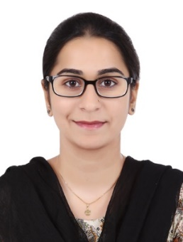
CURRICULUM VITAE

Mahnoor

Mahnoor-392489@2freemail.com

Objective:
To secure a position in an organization that would fully employ my personal skills, my experience as well as my academic training in a rewarding career that affords professional and personal growth.
Professional Summary:

Experienced software engineer with a passion for developing innovative programs that expedite the efficiency and effectiveness of organizational success. Well-versed in technology and writing code to create systems that are reliable and user-friendly. Skilled leader who has the proven ability to motivate, educate, and manage a team of professionals to build software programs and effectively track changes. Confident communicator, strategic thinker, and innovative creator to develop software that is customized to meet a company’s organizational needs, highlight their core competencies, and further their success.

Experience:

Resource Planning Analyst (Core Solutions) (March 2018 to Feb 2019)

Prepare budget and resource analyses, including graphs, reports, statistical analyses, and forecasts. Analyze and report on current and predicted volume or sales information to inform decision-makers.

Software Engineer (Soft Beats) ( Nov 2017 to Feb 2018)
Developed and designed three critical software programs for financial tracking and reporting.
Optimized user effectiveness by creating a detailed feedback queue for users to discuss functionality, convenience, and effectiveness.
Oversee a team of four software developers and lead weekly discussions to brainstorm ideas in software development and to track changes made in existing programs.
Event Organizer/College Discipline: (Jun 2013 to Aug 2014) (Kips College) Discipline Committee Member
Manage all pre-event planning, organizing guest speakers and delegate packs. Coordinate suppliers, handle client queries and troubleshoot on the day of the event to ensure that all runs smoothly and to budget. Manage a team of staff, giving full briefings.

Education Qualifications:

BSSE | 2014-2018 | University of lahore, main campus raiwind road lahore
- Major: Software Engineering, Minor: Computer Science, Mathematics and related courses

Intermediate (ICS) | 2012-2014 | Kips college for girls, johar town branch
- Major: Computer Science, Minor: Physics and Mathematics

Skills & Abilities:
-Well-versed in software tools including HTML, JavaScript, CSS, Backbone & JQuery, among others.
-Skilled at reading, writing code using viable inputs & outputs after accurate assessment of pre and post-conditions. Backend services, and user interfaces.
-Confident problem-solving abilities
-Strong communication skills

Computer Skills:
- C language, C++ language
- Complete Microsoft word, excel, power point
- Web development on MVC (PHP framework larvael, WordPress)
- Command on Maude tool, SQL, Xampp
- Theory of automata, discrete structures and human computer interaction.
- Documentation writing command (SRS and testing documents).

Personal Profile:
Date of Birth : August 24, 1995
Nationality : Pakistan
Marital Status : Married
Languages : English, Urdu, Punjabi
Visa Type : Visit Visa

