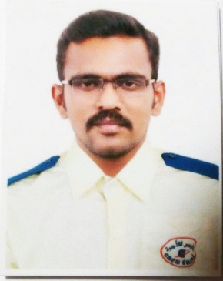
MUKILAN

mukilan-392492@2freemail.com

--------------------------------------------------------------------------------------------------------------------------------------------------------
Career Objective :
To Work efficiently in a reputed organization and to achieve professional excellence.

Educational Qualifications :
Completed SSLC at Mahatma Matriculation Hr Sec School under Matriculation
School of Education Tamilnadu of 63% in 2004.

Discontinued DEEE.
Experience Details :
Worked as Electronics Sales Executive at Supertronic L.L.C in dubai 2008-2013.
Worked as a Taxi Driver at Cars taxi L.L.C dubai 2017-2019.

Personal Profile :
D.O.B : 26-07-1987
Visa Status : Cancelled
Religion : Hindu
Driving Licence : Driving licence valid upto 7th March 2020
Languages : Tamil, English, Hindi, Arabic

