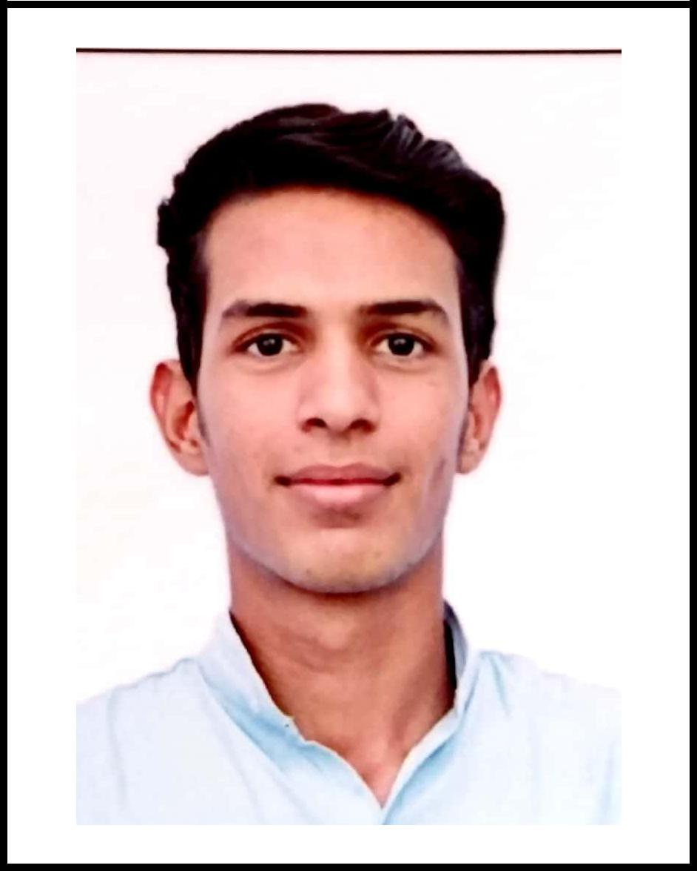
Mohammed
Mohammed-392514@2freemail.com

TO APPLY:-

For Mechanical Engineer

CAREER OBJECTIVE:-

To work in a challenging and professional business environment and to excel in all assignments that I take up in my professional career, so as to make a meaningful contribution to the organization which can provide wide ranging exposure and sufficient responsibilities to upsurge my skills and knowledge.

PROFESSIONAL CREDENTIALS:-

- Pursued Bachelor of Engineering in Mechanical from B.R. Harne college, Affiliated to University of Mumbai Secured 6.84/10 CGPA till 7th semester.

Examination | Year of Passing | University / | CGPA
 |  | Board
T.E | 2017-2018 | Mumbai University | 6.12
S.E | 2016 - 2017 | Mumbai University | 7.20
F.E | 2015 - 2016 | Mumbai University | 7.03

ACADEMIC CREDENTIALS:-

Examination | College/School | University/ | Year of Passing | Percentage
 |  | Board
H.S.C. | Shriniwas Bagarka College | Maharashtra | 2015 | 66%
 |  | Board
S.S.C. | City Convent School | Maharashtra | 2013 | 55%
 |  | Board

TECHNICAL QUALIFICATION & SKILLS:-

- Certification course on Solid modeling and Engineering application of solid works & sketching of 2D & 3D using Autocad.

-Authorized by Govt. of India (National skills training institute – Mumbai)
- Internship at Indian Railway –Carriage workshop, Central Railway Matunga

➢ Basic 2D/3D Drafting software : Solidworks, Autocad, CATIA v5

➢ Basic Analysis software : Ansys, Solidworks

➢ Assembling Electronics Circuit and basic Electrical repair.

- Final year project:-

Project title: - Folding Car

Project role: -Designing, Fabrication & Done the analysis

EXTRACURRICULAR ACTIVTITES & HONORS:-

- I worked as a event coordinator with Bespoke Integration which help me to develop my communication skills and team management.

- Sports Champion of my college

- Participated in International design competition 2018 which was conducted by CADD Centre Training services Pvt. Ltd.

- Microsoft office (Word, Power point, Excel)

PERSONAL INFORMATION:-

Nationality : Indian

Date of Birth : 21st October, 1997

Marital Status : Unmarried

Gender : Male

Language : English & Hindi

