CURRICULUM VITAE

Personal Information

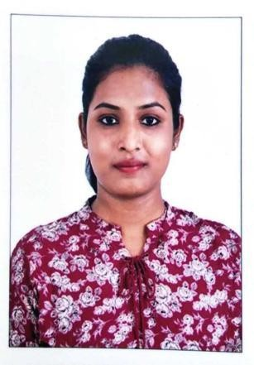Name : RETHU
Date of Birth : 07.0.7.1996
Gender (M/ F) : F
Present Citizenship : INDIAN
E-mail : rethu-392522@2freemail.com
Visa status : VISIT VISA.

Working Experience:

SLNo | Name of the Firm/Organization | Role / Designation | Period of working |  | Total Years of Working | Types of work handled
 |  |  | From | To
1 | RR Construction and building planners | Junior Architect | Jan 2018 | March 2019 | 1yr 2months | Detail Drawings, 3D Works, Interior works, Material selection,Preparing government approval drawings Site observation.
2 | Interface Architects | Intern | Dec 2016 | Oct 2017 | 11 | Detail Drawings, 3D Works, Interior works, Material selection, Landscape designing..

Projects worked on:
- COMMERCIAL SPACE: 1. hospital, 2 shopping malls, 2 restaurants, 1 wine cellar, 1 office space,
RESIDENTIAL SPACE : 8-10 residential works. From 2016-2017
- COMMERCIAL SPACE: 1complex, 1tiles show room, 1Furniture showroom front facade,
Government approval drawings and estimation,
RESIDENTIAL SPACE : 5 residential projects.

Educational Background:

Course | Year | Name of School/College/  University | Place and State | % / Grade
Professional Degree- B.ARCH | 2013-2018 | Karpagam Academy of higher Education | Coimbatore , Tamilnadu. | B-79%
HSC / Equivalent | 2012-2013 | SVGV matric higher  secondary school | Coimbatore, Tamilnadu | 75%
SSC / Equivalent | 2010-2011 | L.E.F christian matric school | Coimbatore, Tamilnadu | 85.4%

Workshops and seminars:
  - SEPT 2017: ANNUAL MASA EVENT, BANGALORE..
  - SEPT 2016: INTERNATIONAL CONFERENCE ON INFORMAL SETTLEMENTS IN INDIA- BUILDING INCLUSIVE URBAN COMMUNITIES (BINUCOM).
  - AUG 2015: 2 DAYS WORKSHOP FERROCEMENT AS AN ALTERNATE MATERIAL, CONDUCTED BY AUROVILLE, PONDICHERRY.
  - MAR 2014: 3 DAYS ANIMATION WORKSHOP, CHENNAI
  - MAR 2014: 3 DAYS BAMBOO WORKSHOP, COIMBATORE

Competitions and other program:
- JAN 2019 BIENNALE, COCHIN.
- MEMBER OF RESEARCH PROGRAMME (2016) IN COLLABORATION WITH DANUBE UNIVERSITY, AUSTRIA- ABOUT INFORMAL SETTLEMENTS IN INDIA.
- ANNUAL NASA DESIGN COMPETITION (ANDC) 2015- SHORTLISTED ENTRY- TOP60 IN INDIA.

Technical field of interest:
- MATERIAL STUDIES.
- CONCEPTUAL DESIGNING.
- SUSTAINABLE ARCHITECTURE.
- VISIONARY ARCHITECTURE.

Language Proficiency:

Language | English | Hindi | Tamil
Speak | ✓ |  | ✓
Read | ✓ | ✓ | ✓
Write | ✓ | ✓ | ✓
Computer Proficiency:

Course | MS Office | Auto CAD | V-ray | Sketch-up | Photoshop | Revit | Rhino
Excellent | ✓
Good |  | ✓ |  | ✓ | ✓
Fair |  |  | ✓ |  |  | ✓ | ✓

