SAKARIYA

ACCOUNTANT
Sakariya-392546@2freemail.com

In quest of professional opportunities for utilizing my skills and abilities in computerized industries that offers professional growth while being resourceful, innovative and flexible. Willing to work as a key player in challenging and creative environment.

Contact Information
Skills
- SAP Accounting
- Tally ERP9
- Excel
- Peachtree
- QuickBooks
- Payrolls
- Microsoft Ofﬁce

Languages
- English
- Arabic
- Hindi
Malayalam

Experience

MUHAMMADIYYA SUPERMARKET
AL Kunfudha Saudi Arabia March 2018 to
May 2019

CELLKING ASSOCIATES
Kerala-India September-2015 to February 2018

Accountant
- Keeping accounts of supplies and Customers account
- Accounting activities up to ﬁnalization of accounts.
- Preparation of Credit Note, Debit Note, Stock, Postdated Cheque (PDC) etc.
- Computerization of accounts using Tally9.
- Developed experience of Excel Spreadsheet and M.S Word.
- Handle all the other responsibilities related to the job.
- Preparation of bank reconciliation statements.
- Documents ﬁnancial transactions by entering account information.
- Preparation of Stock Summary.

Accountant
- Accounting activities up to ﬁnalization of accounts.
- Preparation of Credit Note, Debit Note, Stock, Post Dated Cheque (PDC)etc.
- Maintenance of various accounting registers for Purchases
and sales

- Preparation of Salary for all employees of the company. (payroll)
- Preparation of Income & Expenditure Statements for different types of business.
- Preparation of bank reconciliation statements.
- Preparation of Stock Summary.

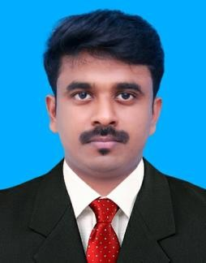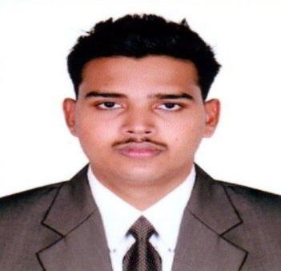Personal Details

Indian Male Single
Date of birth:19/08/1994

Current location: Dubai

Visa status: visiting visa

Educational profile
- PG DIPLOMA IN INDIAN AND FOREIGN ACCOUNTING(PGDIFA)

IPA PERINTHALMANNA KERALA INDIA
May 2016

- MASTER OF COMMERCE

BHARATHIAR UNIVERSITY COIMBATORE
Tamilnadu, India May 2017

BACHELOR OF COMMERCE

ST, MARYS COLLEGE PUTHANANGADI UNIVERSITY OF CALICUT
Kerala India May 2015

HIGHER SECONDARY EXAMINATION
BOARD OF HIGHER SECONDARY EXAMINATION GVT OF KERALA, INDIA(May 2012)

SECONDARY SCHOOL LEAVING CERTIFICATE
Dept. of General Education-Gvt. Of Kerala, India

