CURRICULUM VITAE
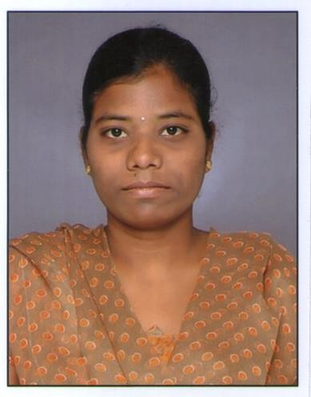
(Accountant) – On Visit Visa (UAE)

Renuka

renuka-392554@2freemail.com

Academic Achievement

- S.S.C. – 51.00%

- H.S.C. (CS) – 42.00%

- B.Com (Vocational) – 60.00% (First Division)

- M.Com (Commerce) – 46.30% (Second Division)

- P.G. Diploma in Computer Application - 69.16% (First Division)

- Typing Lower Grade 30 W.P.M

Experience
- Worked as a Junior Assistant at Cognizant College of Commerce and

Science at Ameerpet, Hyderabad [18th January 2013 and 17th January 2014]

- Worked as a Accounts Assistant Australian College of Business and Management at Ameerpet, Hyderabad [February 2014 to March 2015]
- Worked as a Accounts Executive at Wellness Hospital Ameerpet, Hyderabad

[August 20th 2018 to 15th May 2019]

Worked At
Worked as a Data Entry at Karvy, Madhapur Hyderabad [6 Months Target Based]

Worked as a Data Entry at Prabhan Solution Pvt Ltd, Ameerpet, Hyderabad.

[6 Months Target Based]

Worked as a Front Office at Delloite E Block and A, D Block at High-Tech City Hyderabad [1 Year]

Worked as a Health Products Sales person Part time Business Tianshi Pvt. Ltd at Luxor Park, Banjara hills, Hyderabad [ 1 ½ Year ]

Worked as a Accounts at Bosch Showroom at Balanagar, Hyderabad [3 Months]

Worked as a Accounts at Ganga Jewelers at KPHP Hyderabad [3 Months]

General Awarenes

» MS OFFICE Package: Word, Excel, PowerPoint, Access, Office.

» TALLY ERP 9: Journal Entry’s, Bank Receipts and Payments, Purchases, and Sales, Cash Voucher entries, Bank Voucher entries, Insurance Bills, Final Bills.

» Cash Handling, Cash Process, Cash Inflow, Cash Outflow Filing, Salary Preparations, Salary Issued, Book Keeping, Cash Tractions.

» DTP – Photoshop

Languages Know

- English (Writing, Reading, Understanding, Speaking)
- Hindi (Writing, Reading, Understanding, Speaking)
- Telugu ( Writing, Reading Understanding, Speaking)

Hobbie

- Listening Music
- Dancing
- Cooking
- Reading Books
- Browsing

Skill

- Positive Attitude
- Zeal to learn
- Easily adaptable to any work conditions
- Good work control under pressure

