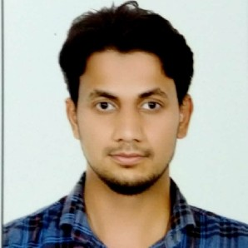
WASEEM
waseem-392559@2freemail.com

CAREER OBJECTIVE
To obtain a position that will enable me to use my strong organizational skills, award-winning educational background, and ability to work well with people.

EDUCATION
V.T.U. Belgaum Mechanical engineering 75%
2018

Poorna Prajna pre-university college, Udupi
Pre-university college 83%
2011

Salihath High School,Hoode
Metric 89.50%
2009

CERTIFICATIONS
Diploma in HVAC & Fire Fighting-MEP(Designing & drafting)
Published the paper on "Mechanical characterization of Al-Fe composite" in International Journal of Advanced Research, Ideas and Innovations in Technology (IJARIIT) Volume-4, Issue-3, May-June-2018, ISSN:2454-132X

TECHNICAL SKILLS
Languages: Java programming, C programming. Design softwares: AutoCAD, Solid edge.
Ofﬁce suite: Microsoft (PowerPoint, word, excel). Analysis software: Ansys.

PROJECTS

Mechanical characterization of Al-Fe composite.
To manufacture the Al-Fe composite & ﬁnd it's mechanical properties like tensile strength, compression strength, hardness & wear resistance.

Designing of HVAC system for community building.
4 months

2 months

To calculate the required capacity of machines needed to provide complete heating, ventilation & air conditioning.
To provide the ducting & piping systems required and represent it with the help of AutoCAD drawing.

PERSONAL STRENGTHS
- Always motivated.
- Capacity to complete the hard work skillfully.
- Strong communication and interpersonal skills.
- Quick learner.

INTERESTS
Thermodynamics and Heat transfer. Management .
Designing of mechanical parts. Mathematics.
Education.

PERSONAL PROFILE

Date of Birth : 16/05/1993
Marital Status : Single
Nationality : Indian
Known Languages : English, Hindi, Kannada, Urdu, Tulu, Nawayati
Hobby : Playing football and cricket. Reading books. Following football game.

