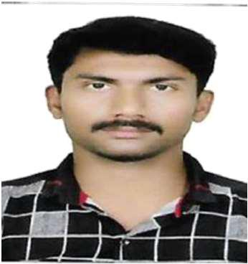
SHAHUL

Shahul-392574@2freemail.com

Dubai, UAE.

PROFESSIONAL SUMMARY

Highly skilled and resourceful Civil Site Co-coordinator with excellent record of cost-effective project completion. Able to function effectively as an independent worker or as part of a team. Exceptionally proficient at identifying and preventing waste water contamination through preventive troubleshooting.

ACADEMIC DETAILS

Diploma in Civil Engineering from AL-AMEEN POLYTECHNIC COLLEGE with 72% SSLC from MATRIC BOARD in 2011 with First class

SKILL SET

AUTOCAD MS Office

WORK EXPERIENCE & ROLES AND RESPONSIBILITIES

Working in Al Mukthar, Abha-Saudi Arabia (April 2017 to April 2018)

Placed orders for housekeeping supplies and guest toiletries. Directed team of 15 to 20 personnel in busy hotel
Improved process efficiency through effective inventory control in alignment with client standards.

Trained and mentored all new personnel to maximize quality of service and performance.

Introduced new operational programs like incentives to increase company loyalty and reduce employee turnover.

Created and implemented training programs to enhance employee performance. Communicated repair needs to maintenance staff.

Completed schedules, shift reports and other business documentation. Worked with front desk to respond promptly to all guest request

Working in Al Hoot, muscut-Oman (Dec 2018 to April 2019)
Creating Customer Billing

Creating work orders for handling jobs.

Assigning and Closing the work orders in Company Software Resolving the complaints via Email and through phone calls. Reporting the labor manpower

WORKING RELATIONSHIPS

Internal: Report to General Manager, Property Stream General Managers & their teams Finance, Marketing & Human Resources.

COMPETENCIES

a. Preference for action – self‐starter with the personal drive and motivation to

Proactively identify issues, progress activities and deliver solutions.

b. Communication – Excellent interpersonal and communication skill with the

Ability to give clear and precise instruction to third parties. Excellent written And verbal communication at all levels is vital to this role.

c. Professional knowledge and Analytical thinking – Strong, rationale thinking

With a challenging, questioning mind that can view issues as a whole as Well as drill down into the final detail.

PERSONAL DETAILS

Nationality : Indian

Date Of Birth : 21/03/1995

Married Status : Single

Visa Status : Visit Visa (Expires on May17 2019)

Languages Known: Tamil, English, Arabic and Malayalam.

DECLARATION

I hereby assure that the above-furnished details are true to the best of my knowledge and belief. I also assure that I will be truthful and dutiful to the job assigned to me.

Date:

Place: Dubai

SHAHUL

