CURRICULUMVITAE

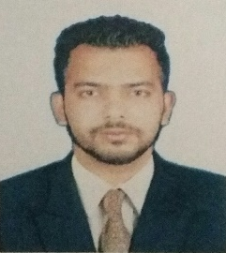

Talha
Email: talha-392802@2freemail.com

Career Objectives:

- To work in an organization where I can utilize my skills and knowledge for the growth and development of the Organization.
- Hard working & achieving goals in all aspects.
- Achievement is prosperity in life.

Personal Skills:

- Excellent organizational and Interpersonal Communication Skills
- Energetic and Enthusiastic
- Can communicate fluently in English, Urdu, Hindi and Marathi.
- Good team worker and very co operative
- Ability to produce quality result in time.

Education Qualification:

- 10th SSC Board (English)
Institution: Maharashtra Board.

- 12th HSC Board (English)
Institution: Maharashtra Board.

- B.Com Bachelor of Commerce(English)
Institution: Jodhpur National University.
Work Experience:

- Worked as Sales Executive fromMarch 2011 to April 2014.
- Worked as Sales Executive from April 2014 to May 2019.

Computer Skill Profile:

- All Operating System of Windows.
- Well operating knowledge ofMS-Office(MS- word, excel &Power Point).
- Basic computer skills & concept

Strengths:

- Good Communicational Skills.
- Dedicated and Hardworking
- Exceptional knowledge of Islamic studies.
- Thorough Knowledge of teaching at various levels and age groups.
- Strong verbal and Written Communication Skills

Personnel Details:

- Date of Birth: 21-Aug-1992
- Nationality: Indian
- Religion: Islam
- Gender: Male
- Marital Status: Single
- Language Known: English, Hindi, Urdu& Marathi
- Hobbies: Reading, Playing Cricket& swimming.

NOTE: The above given information are true correct and complete to the best of my knowledge and belief.

