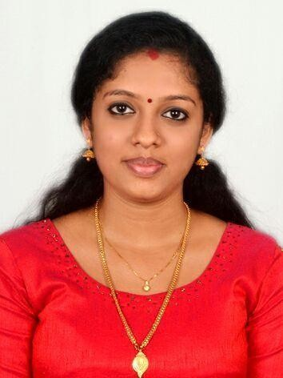
OBJECTIVE
DRISYA

drisya-392808@2freemail.com

Seeking a challenging position is a well-established firm where I can leverage my academic knowledge, skills and experience that shall yield the dual benefits of mutual growth and success.

WORK EXPERIENCE

PROFESSIONAL ACRYLIC MEG & PE LLC
AL QUOZ, DUBAI (Still working)

ACCOUNTANT

- Preparing financial documents such as invoices, bills and accounts payable and receivable
- Completing financial reports on regular basis and providing information to the finance team
- Assisting with budgets
- Completing bank reconciliations
- Entering financial information in to appropriate software programs
- Verifying bank deposits
- Managing day to day transactions
- Reporting on debtors & creditors
- Preparing Quotations.
- Coordinating office activities and operations to secure efficiency and compliance to company policies
- Supervising administrative staff and dividing responsibilities to ensure performance
- Manage phone calls and correspondence (e-mail, letters, packages etc.)
- Create and update records and databases with personnel, financial and other data
- Track stocks of office supplies and place orders when necessary
- VAT Filling
- Providing timely, accurate, and appropriate financial analysis, and information’s.
- Expertly handle accounts, payments, and refunds.
- Provide exceptional clerical supports to senior staff.
- Manage financial statements and organize data for executives.
- Maintaining accounting documents and records.
- Posting supplier invoices to the accounts system
- Preparing bank deposits, general ledger posting and statements

MULTI LINE EXPORTERS

CLERICAL STAFF IN ACCOUNTS APRIL 2016 to MARCH 2017

- Providing timely, accurate, and appropriate financial analysis, and information’s.

- Expertly handle accounts, payments, and refunds.

- Provide exceptional clerical supports to senior staff.

- Manage financial statements and organize data for executives.

- Maintaining accounting documents and records.

- Posting supplier invoices to the accounts system

- Preparing bank deposits, general ledger posting and statements

TINTO THOMAS ASSOCIATES THRISSUR INDIA

OFFICE STAFF AND ESI PF CONSULTANT JULY 2017 to APRIL 2018

- Maintain employee records their personal files etc.

- Filling online ESI AND PF challans.

- All time office work.

- Issue to all employee access card and related work.

- To maintain proper and accuracy timing of incoming and outgoing for the employees.

- Generate employee master, salary details with contact details and pay structure.

- Payroll processing.

- Online employee registration.

- Generate monthly salary for the employees.

- Answering all incoming calls and then transferring them to the relevant person or department.

EDUCATION | ST. THOMAS EDUCATION CENTRE THRISSUR
 | BACHELOR OF COMMERCE in Finance and Marketing Dual Specialization
 | 2014-17

PJMSGHS KANDASSANKADAVU THRISSUR INDIA

Board Of Higher Secondary Examination 2012-14

IJGHS ARANATTUKARA THRISSUR INDIA

Secondary School Certificate 2011

KEY SKILLS TECHNICAL SKILLS

  - MS Excel

  - MS Word

  - MS PowerPoint

  - Creating and Maintaining Data Base

  - Office Equipment – printers, scanners, mailing

ADMINISTRATIVE SKILLS

  - Maintaining and Documenting important files

  - Appointments

  - Taking Minutes of Meeting

  - Preparing reports

  - Organizing meetings

COMMUNICATION SKILLS
- Correspondence

- Written/Verbal communication

• | Customer service
. | Processing telephone calls
PERSONAL CHARACTERISTICS
 | - Active Listening
 | - Sociable with pleasing personality
 | - Energetic
 | - Initiative
 | - Self-Motivated
 | - Maintaining Confidentiality
 | - Self Confidence
PERSONAL DETAILS
Date of Birth – 9th Aug 1996
Nationality - Indian
Hobbies – Reading, Listening

