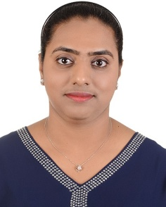
Name: Karishma
Date of Birth: 12th December 1993
Nationality: Indian

karishma-392811@2freemail.com

OBJECTIVE
Find a challenging and motivating job to increase my work knowledge, experience, to practice theoretical knowledge learnt over the years, in a dynamic and energetic organization that can help bring out the best in me.

ACADEMIC DETAILS
- MA Human Resources (CIPD Accredited) Middlesex University Dubai Year 2017
- BA hons in Business Administration Middlesex University in Dubai Year 2015
- High School Diploma from Our Own Indian School Dubai Year 2012

EXPERIENCE
HR Intern at Mövenpick Ibn Battuta Gate Dubai 20 May to 30 November 2018
  - Assisted in reviewing HR policies and procedures.
  - Booking of vacations tickets of colleagues.
  - Assisted in maintaining employee personal files.
  - Assisted in recruitment/on boarding of new employees.
  - Assisted in making monthly HR reports.
  - Assisted in daily admin work.
  - Assisted with the staff cafeteria needs.
  - Assisted in the monthly employee events.
  - Assisted in the team gathering.
  - Assisted in annual employee engagement survey.

HR Internship at Atlantis the Palm Dubai 8 June to 4 September Year 2014
  - Assisted with visa application and renewal of visa process.
  - Assisted with setting new organization system for HR files.
  - Attended and assisted with the following trainings;
    - Resort Orientation and service academy,
    - Group training techniques,
    - Effective supervision,
    - Workplace ethics,
    - Essential non-verbal behaviors.
  - Tasks also include preparation of new work contracts and Employee engagement survey.

COMPUTER SKILLS ACQUIRED
Professional software Micros Material Control (FMC)
HITS HR software
Operating System Microsoft & Apple IOS Application Packages MS Office, ADOBE.
Internet Can Handle Social Media Tools.

INTERESTS
HR department, web surfing and searching, attending Seminars & Exhibitions, travel and tourism. Learning about new cultures.

MAJOR STRENGTH/SKILS
  - Can get along in teams and have an awareness of different cultural background.
  - Experience in the HR Department with diverse culture.
  - Honest and dedicated in my work and ready for challenges.
  - Effective communication Skills.
  - Presentation Skills.

