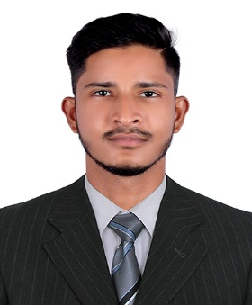

To work in a firm with a professional work driven environment where I can utilize and apply my engineering and technical knowledge, skills which would enable me to grow while fulfilling organizational goals.

**Hussain**

**Interests**

* To know about latest technology
* Interested in production and manufacturing sectors
* Reading books, listening music and passionate about football

**Skills**

* ANSYS
* Excellent in workshop and machine shop
* AutoCAD
* MS Office
* Analytical in nature

**Language**

English

Hindi

Marathi

Tamil

**Personal Info**

**Email**

[Hussain-392840@2freemail.com](mailto:Hussain-392840@2freemail.com)

**Projects and Achievements**

2013-14 Stood second in Robo war Competition and represented my college at IIT-Bombay for a PPT Competition.

2014-15 Prepared a Model to detect smoke in a closed environment i.e. Smoke detector

2016-17 Became Sports Secretary of college & played in the university football team

2018-19 Made a working model of “AUTOMATED CAR PARKING SYSTEM” as my final year project.

**Education**

**2018-19 Bachelor in Mechanical Engineering** Mumbai University

7.60 CGPA

**2012-13 Higher Secondary School Certificate**

Karmaveer Bhaurao Patil college, Vashi

52.00 %

**2010-11 Secondary School Certificate**

Anjuman-I-Islam AAK high school

82.55 %