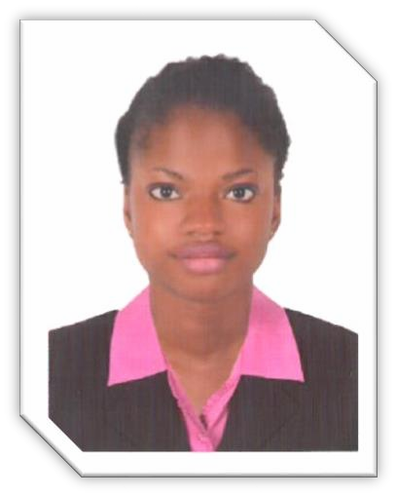
JEREMIAH

Jeremiah-392847@2freemail.com

POST APPLY FOR: WAITRESS

CAREER OBJECTIVE
Outgoing waitress offering extensive knowledge of hospitality etiquette, food preparation, and superior service. Organized, independent professional offering 5years experienced in the food service industry. Detail-Orientated with strong time management skills and ability to learn new tasks quickly.

EDUCATIONAL QUALIFICATION:
- Diploma in Philosophy (undergraduate)

WORK EXPERIENCE

  - Worked as a waitress in a 4-star Hotel – Lagos , Nigeria ( 2016-2017)

DUTIES AND RESPONSIBILITIES
Offer welcome drinks and beverages Fill water glasses and refill beverages. Offer appetizers
Take orders and provide information about menu items
Suggest menu items when requested by the customer
Replay patrons orders to the kitchen
Ensure that the order is prepared according to the menu
Ensure order quality and quantity prior to serving Serve meals and side dishes
Deliver Food carts to designated areas
Ensure that continued service is managed during the course of the meal
Keep a constant eye on the table to gauge needs and fulfill them immediately

PERSONAL DETAILS  DOB : 2 DEC 1999  SEX : FEMALE  MARITUL STATUS : Single NATIONALITY : NIGERIA  RELIGION : Christian LANGUAGES KNOWN : ENGLISH | II) WORK EXPERIENCE  Worked as a waitress at Ocean basket Victoria island – Nigeria ( 2017-2018)  DUTIES AND RESPONSIBILITIES  Cleaned tables, removed dirty dishes, and replaced table linens.  Replenished clean linens, glassware, silverware, and dishes.  Supplied service staff with food. Served patrons with water, coffee, and condiments.  Cleaned and polished furniture, shelves, walls, and equipment.  Stocked refrigerators with bottled beer and wines.  COMPETENCIES  Hardworking and efficient.  Able to learn new jobs/tasks quickly responsible and attentively.  Can work under pressure  DECLARATION  I hereby declare that all the information provided above are true and correct of my knowledge and belief.

