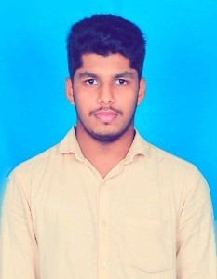

Isubu
isubu-392860@2freemail.com

CAREER OBJECTIVE
Seeking employment with a company where I can use my talents and skills to grow the company.

EXPERIENCE
Nov 2018 to May 2019 Loyal Hospitalitty
Cashier hardly working

EDUCATION
Degree/Course Institute/College University/Board Percentage/CGPA Year of Passing

Goverment First
B.Com Grade College Bettaampady
Mangalore University

Goverment P U College Kanyana
68% 2018
P.UC
K.V.S.MH.S
S.S.L.C
Kurudapadav
Pre-University Banglore
General Education Department

82% 2015

65% 2013

Diplopma In Computer Application
Karnataka Computer Academy
Karnataka Computer Academy

60% 2014

ACHIEVEMENT
Commerce Fest I have organized by inter class commerce fest held by the department of commerce

HOBBIES
Reading News Paper And Hearing Songs,Browsing Internet
PERSONAL DETAILS

Date of Birth 12/09/1997
Gender Male
Nationality India
Marital Status Unmarried
Language Know English, Hindi, Malayalam, Kannada, Tamil

