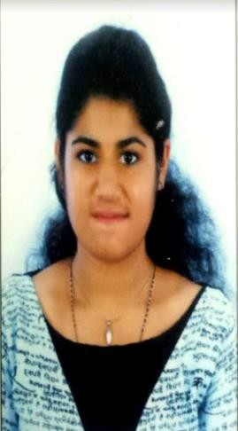
MERLIN

merlin-392861@2freemail.com

CAREER OBJECTIVE:

Seeking for a challenging position as a Civil Engineer, where I can use my planning, designing and overseeing skills in construction and help grow the company to achieve its goal.

ACADEMIC PROFILE:

- B-Tech, Civil Engineering-(2015-2019) -Score 85%
Viswajyothi college of Engineering and Technology(VJCET), Kerala, India (Kerala Technological University(KTU))

- Higher Secondary Education- (CBSE Board) - Score 86% Our Own English High School, Dubai, UAE (2001-2015)

INDUSTRIAL TRAININGS/ INTERNSHIPS:

- Internship program in the Structural Department at Conin Architectural & Engineering Consultancy, Dubai from 10-06-18 to 10-07-18
  - Included design of retaining walls and basement walls on Prokon as well as their manual analysis, truss analysis by method of sections and checking the same in STAAD PRO, basic understanding of steel structures.

Internship program at Kumar&Kumar Architects, Thodupuzha, Kerala from 01-07-2017 to 15-07-2017
  - Included visiting several ongoing and finished construction sites and gained knowledge on different stages of construction process.

Internship program at Alappuzha, Kerala from 19-05-18 to 25-05-18 - CANALPY Project initiated by IIT-Bombay and Kerala Institute of Local Administration (KILA).
  - Included rejuvenation of canals of Alappuzha by conducting socio-economic surveys of households and industries in the local areas nearby the canals, water quality sampling in order to check E.coli bacteria content in dug wells and bore wells, tracking down locations of solid/liquid waste disposal sites along the canals using OSMTracker App.

SOFTWARE SKILLS:

- AUTOCAD
- STADD
- PRIMAVERA
- PROKON
- MS WORD, MS EXCEL, MS POWERPOINT

OTHER SKILLS:

  - Manual Drafting
  - Familiar with using civil engineering survey equipment like Auto Level, Dumpy Level, Vernier Theodolite, Plane Table Set, Total Station.
  - Familiar with using geotechnical, transportation and material testing machines.

PROFESSIONAL ACHIEVEMENTS:

- Attended Virtual Reality Workshop 2017 held at NIT Calicut, Kerala. Included seminars and professional talks on video game development.
- Volunteered in conducting Mindspark, Paper Presentation competition for Technical fest 2017 held at VJCET.
- Participated in Civil Expo, Still Model Competition for Technical fest 2017 held at VJCET.
- Member of ISTE (INDIAN SOCIETY FOR TECHNICAL EDUCATION).
A platform where students express their innovative ideas and implement it.

PROJECT DETAILS:

  - Project Name: Capacity Analysis of Two-Lane Highways
    - To identify the factors affecting the capacity of two-lane highways.
    - To study the effect of various geometric characteristics of the road and traffic factors on the capacity of the roads.
    - To develop mathematical models for predicting capacity as well as operating speed of two lane Highways.

HOBBIES:
- Travelling, visiting places
- Learning new things
- Drawing/Painting
- Photography

PERSONAL PROFILE:

Date of Birth: 07-08-1997
Nationality: Indian
Known languages: English, Malayalam, and Tamil
Visa Status: On mother’s sponsorship

