CONTACTS

govind-392880@2freemail.com

SKILLS

Learning Agility ⬇ ⬇ ⬇ ⬇ ⬇
Leadership and ⬇ ⬇ ⬇ ⬇ ⬇ Team building

Business
planning and |  | ⬇ ⬇ ⬇ ⬇ ⬇
reviews
Strategic
Account |  | ⬇ ⬇ ⬇ ⬇ ⬇
Management
Client |  | ⬇ ⬇ ⬇ ⬇ ⬇
Relationship
Management
LANGUAGES
 |  | English
 | 90%
 |  | Hindi
 | 90%

Spanish

HOBBIES

Traveler

Playing football

Socializing

CURRICULUM VITAE – GOVIND
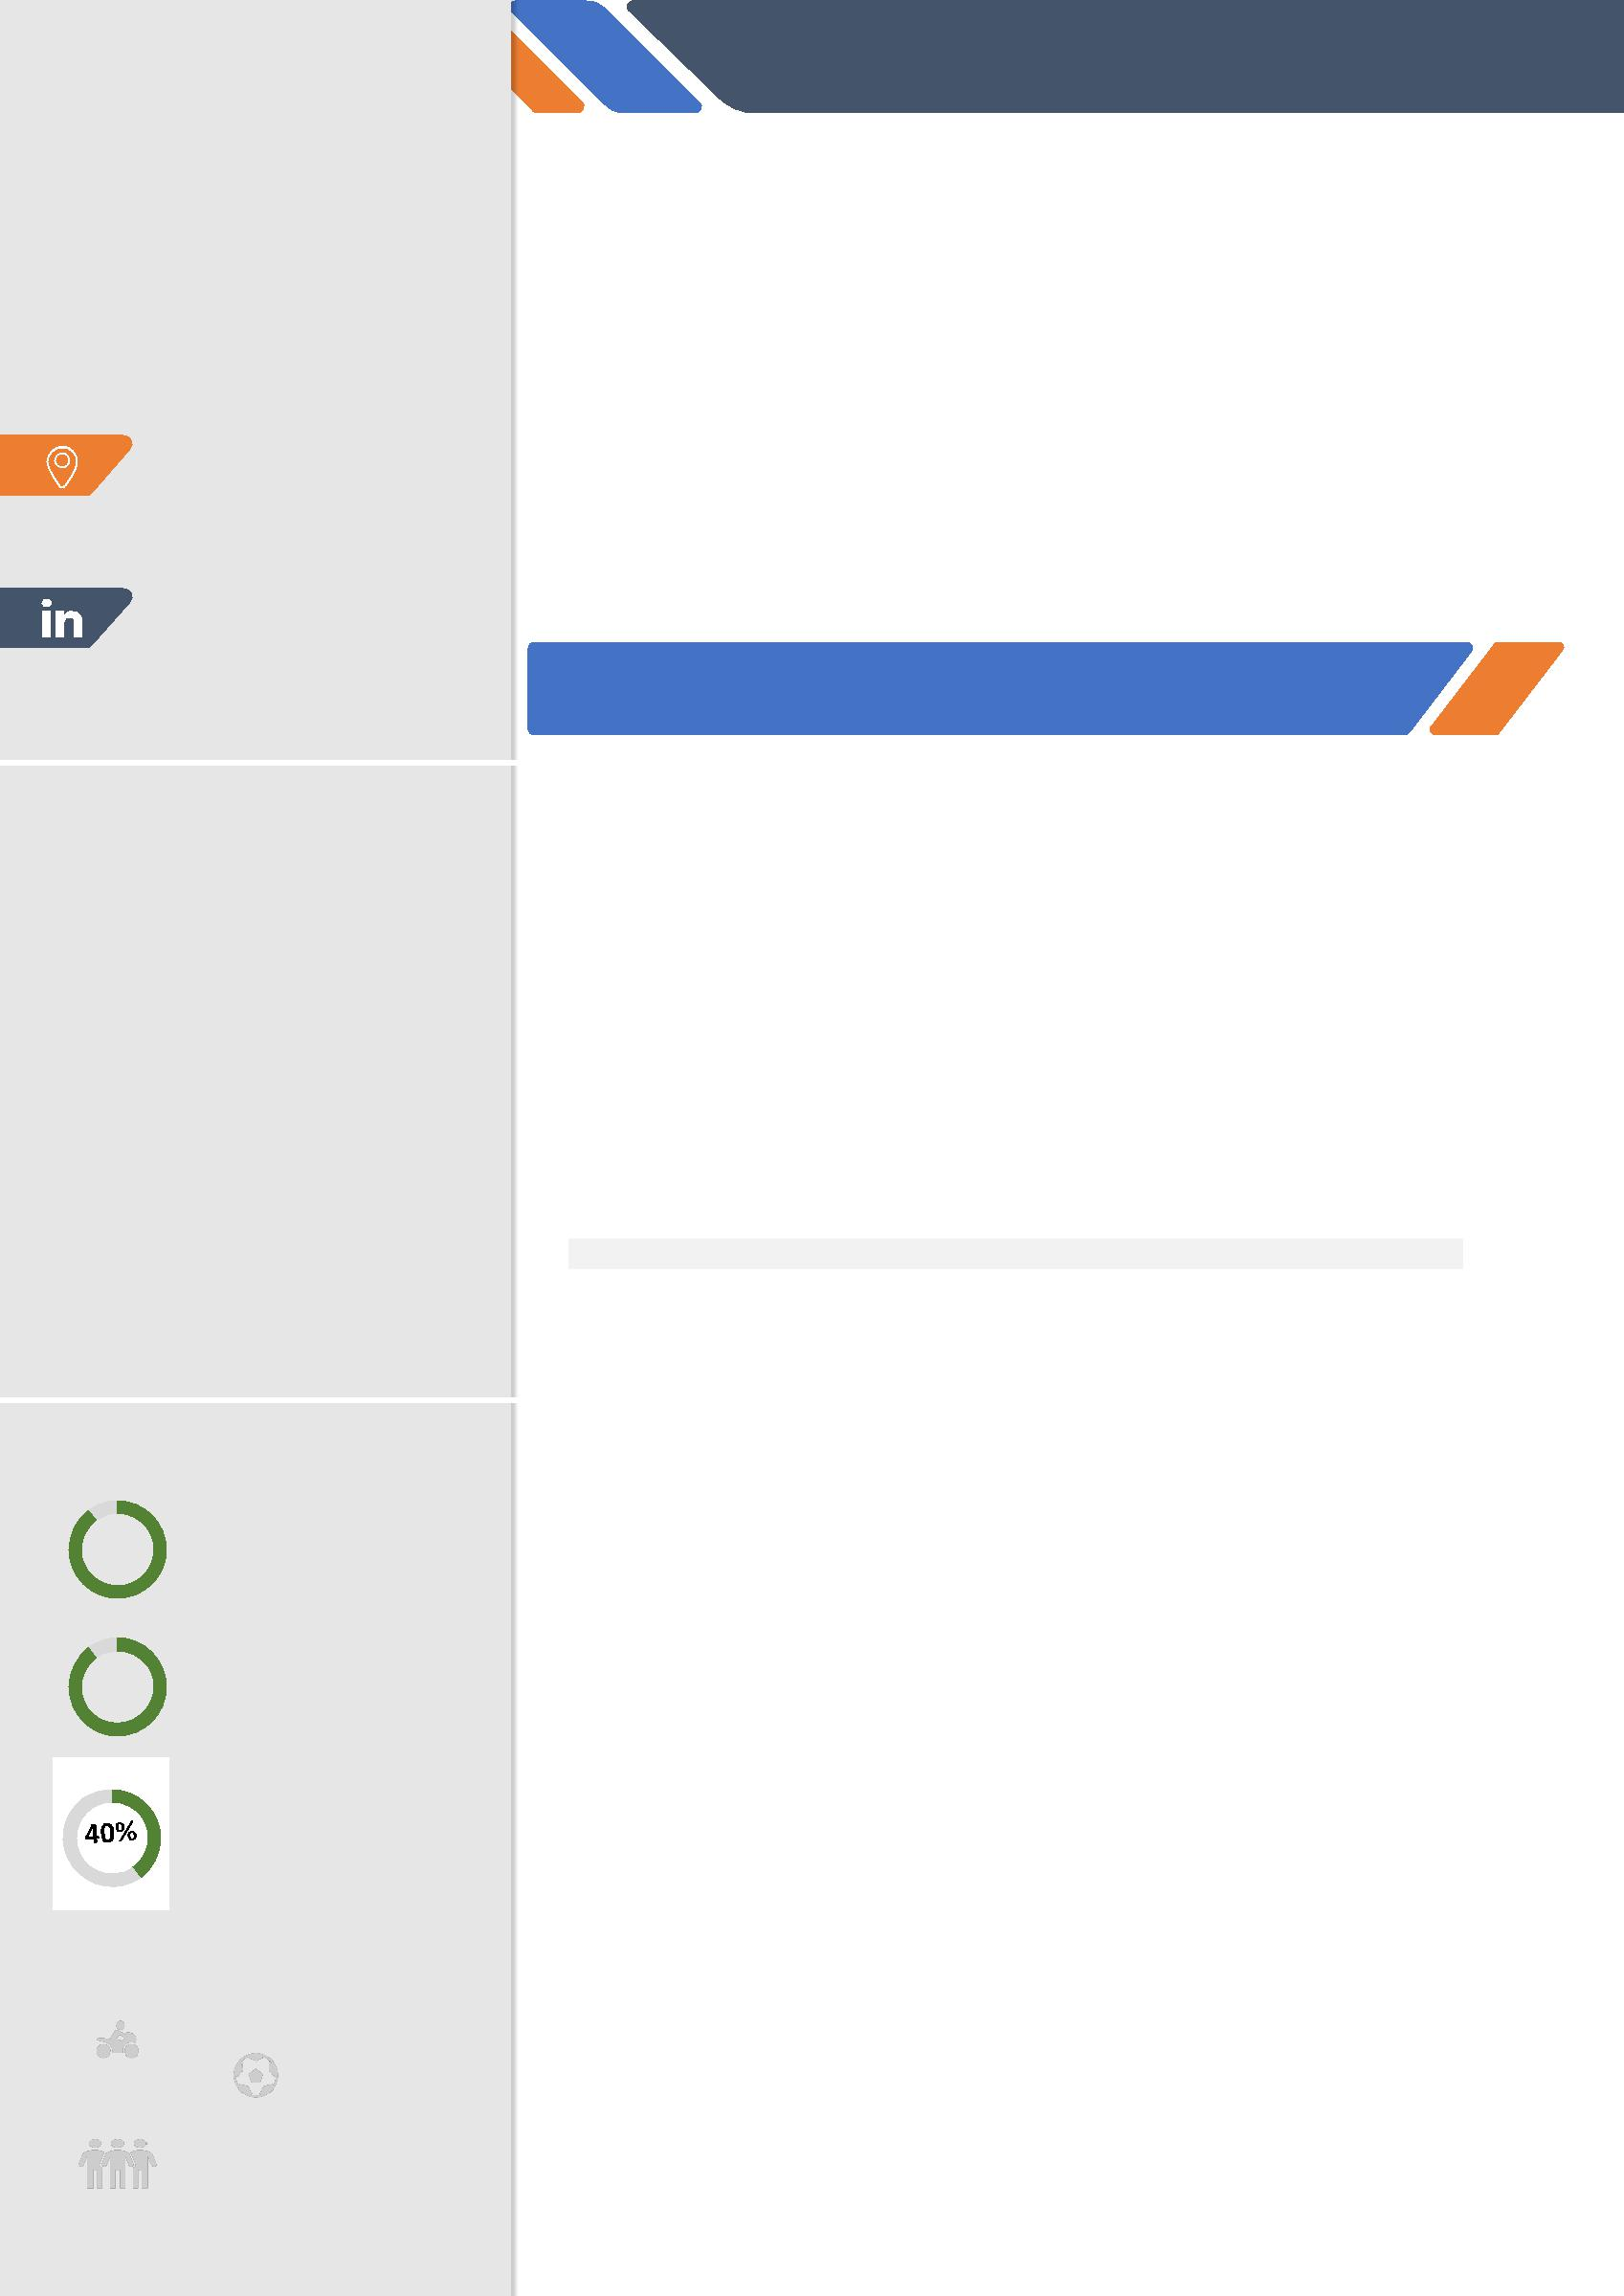

GOVIND KUMAR
SALES EXECUTIVE/ADVISOR-FINANCIAL SECTOR

Comprehending client’s requirements and proposing right mix of solutions is the strategy inflexibly performed by me which has constructed mutual trust and attainment of choice of partner in customer transformation journey.

It is a strong belief that, i possess the financial acumen and commercial flair needed to understand diverse markets and identify potential opportunities and new clients.

High willingness to perform and deliver par expectations is a promise that can be taken from me.

EXPERIENCE

SALES EXECUTIVE/ADVISOR | JUNE.2017 - PRESENT
ICICI-PRUDENTIAL ASSET MANAGEMENT

Managed large and complex customer and prospect relationships to maximize net contribution through an emphasis on obtaining new, high income relationships. Maintained quality service for all customers, expanded existing relationships, monitored relationship profitability and drove revenue growth.

Presently managing 7 ICICI branches across Delhi region as a relationship executive.

Responsible for new asset acquisition and portfolio allocation of over INR 50 crores.

Role and Responsibilities

- Managing a team of approx. 42 people from banking team, who are responsible for generating revenue from existing banking customers.

- Stay abreast of current business and industry trends relevant to the client's business

- Financial Sales Profile - Provide on and off field support to advisors.
- Providing need based “Financial planning for customers”.

- Acquiring knowledge and developing skills on products and process through E-learning modules.
- Imbibe technology platforms to learn & educate about Financial Plans.
- Handling and managing customers and team members.

Major accomplishments:

- Awarded Sales hero of the month -December-2018.

- Grew Branch’s investment portfolio from 30 crores to 36 crores (FY 18-19 target)

- Trained and mentored 3 Relationship Managers in sales and customer retention, improving their skills and confidence

- Managed clients' risk through the implementation of a diverse portfolio including investments, insurance and trust products

- Constructed client portfolios based on asset allocation and historical financial and market data to reduce their investment volatility and risk while increasing returns

CURRICULUM VITAE – GOVIND

BUSINESS DEVELOPMENT MANAGER |  | MARCH.2016 -APRIL.2017
SHRI RAM AUTO TECH PVT. LTD.
Role and Responsibilities

- Marketing of Automated water carts.
- Customer relationship Management
- Generating Sales lead for the sale of product (E.Q.O Water tech)
- Business planning and review
- Pricing and negotiation
- Business Development.

Awards and Recognitions-Overall

- Youngest achiever of the year
- Sales Hero January-2019

EDUCATION

 | Degree |  |  | University/Board |  |  | Percentage |  |  | Year of
 |  |  |  |  |  |  | /CGPA |  |  | Passing
 | MBA |  |  | Swami Vivekananda Subharti |  |  | Result |  | 2018
 |  |  |  | University |  |  | Awaited
 | B. tech+ Mtech |  |  | Amity Institute of |  |  | 6.40 |  | 2016
 | (Nanotechnology) |  |  | Nanotechnology
 | 12TH (Science) |  |  | C.B.S.E/Laxman Public |  | 66% |  |  | 2010
 |  |  |  | School
 | 10TH |  |  | C.B.S.E/Laxman Public |  |  | 66% |  | 2008
 |  |  |  | School

TRAININGS AND PROJECTS

 | Topic |  |  | Topic |  |  | Topic
 | Synthesis of Ido- di sulfde |  |  | 6 months |  |  | ICMAB, Spain
 | acting as a capping agent for
 | gold NP; s for future
 | biomedical application
 | Synthesis and studying the |  |  | 6 months |  |  | Amity University, Noida
 | properties of Graphene
 | quantum dot and Carbon
 | quantum dot for treatment of
 | water purification
 | Sensing and modelling of |  |  | 2 months |  |  | Amity University, Noida
 | Nanomaterial.

CURRICULUM VITAE – GOVIND

TECHNICAL PROFICIENCY

- Microsoft office (Word, PowerPoint)

- LT-SPICE (Simulation Software for constructing different electronic devices)

- Various Characterization Techniques for testing of Samples (UV Spectroscopy,

- Photo Luminescence, AFM,TEM,SEM)
- Bio Informatic

I hereby declare that the above-mentioned information is true and

correct and I bear the responsibility for the accuracy of the above-mentioned details

