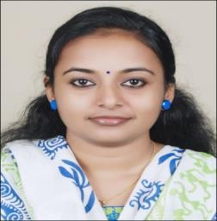
SARANYA
Saranya-392890@2freemail.com

OBJECTIVE:
Seeking a position to utilize my skills and abilities in nursing that offers professional growth while being resourceful, innovative and flexible.

EDUCATION

- BSC Nursing in 2013 XII from India in 2009 X from India in 2007
- AAPC Certified Medical Coder
- ICD 10 CM
- HCPCS Level 2
- CPT
- LOM

PROFESSIONAL EXPERIENCE:

Having 2 yrs. of Experience as Staff Nurse in Manipal Hospital, India

Having 1 year experience as English Fluency Instructor for IELTS course program

Registered with Kerala Nurses and Midwives Council

EXPERIENCE CHRONOLOGY:

  - Organization : Manipal Hospital
Designation : Staff Nurse
Duration : March 2015 to October 2016

During my tenure I was posted in ICU which had 8 critical beds and 6 high dependency beds and I worked with all modern equipment’s.

B. Organization : B-GHUD Academy Private Limited
Designation : English Fluency Instructor
Duration: November 2016 to November 2017
I had been conducting grammar classes, motivational classes and translation.

CERTIFICATIONS:

- AAPC CPC- A

  - Membership Id: 01711307

- B.Sc. NURSING

  - Registration No: KL04201702910

Other Activities

- Active Part in SNA activities in my College
- Contributed articles to my College magazine
- Took part in sports, games and cultural programs
- Attend medical camps offered by agencies

PERSONAL DETAILS:-

- Nationality : Indian
- Date of Birth : 15-02-1991
- Sex : Female
- Marital status : Married
India
- Languages Known : English – Malayalam – Hindi- Kannada

