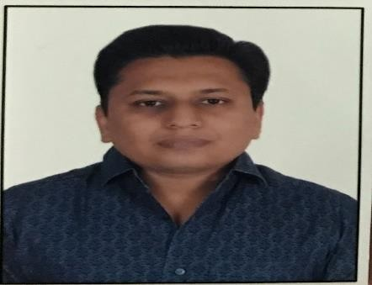
CURRICULUM VITAE

PERSONAL DETAILS - MITESH

Email: mitesh-392893@2freemail.com

CAREER OBJECTIVE

To Be a successful professional in a Globally Respected company and to achieve the objective of the company with Honesty and fairness & to continuously upgrade my knowledge & Skills.

EDUCATION HISTORY

March 2010 Post Graduation Diploma in Entrepreneurship & Services Management.
Entrepreneurship Development Institute of India (EDI)
Gandhinagar, India

March 2008 Master of Science in Organic chemistry from Gujarat University, India

WORK EXPERIENCE

April 2010– June2019 Working as a CLUSTER MANAGER at Planet Health- a Medical and wellness Retail Chain-Ahmedabad India
Job Profile:
Handling P&L of the store.
Responsible for sales in the store, achieving the Daily, Weekly & Monthly targets. Cost monitoring and ensuring expenditure is within the budget allocated.
Maintaining the Cash Flow, controlling the expenses and increasing the profits. Analyzing the fast and the slow moving products and working on them accordingly Effective & attractive visual merchandising of products.
Carrying out promotional activities for generating a higher number of footfalls in the store

To establish brand and customer loyalty
Placing order with the distribution department for merchandise requirement based on sales Provide and maintain high level of customer service and customer satisfaction.

COMMUNITY INVOLVEMENT & RECOGNISED ACHIEVEMENTS

- Served as President in Agrawal sewa yatra.

OTHER SKILLS AND CERTIFICATES

Computer Skills:Well versed with Microsoft office & surfing.
- Done a 1 year computer Certificate course from Bhavans R A college.
- Won Best Handwriting competition at Higher secondary
- Won Gold Medal in Master in science by obtaining 1st position.
- Got Trophy at Planet Health by executing Highest sale during Republic schemes.

Language Known: English, Hindi & Gujarati PERSONAL COMPETENCIES

- Ability to work in a fast-paced environment to set deadlines
- Excellent oral and written correspondence with an exceptional attention to detail
- Highly organized with a creative flair for project work
- Enthusiastic self-starter who contributes well to the team

INTERESTS AND ACTIVITIES

Teaching, playing Guitar

