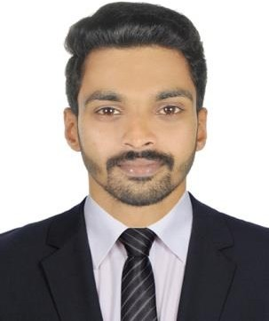
ANANDHU
anandhu-392897@2freemail.com

CAREER OBJECTIVE
Seeking a vital finance professional role in an organization where I could apply my skills in market research, investments, fund raising, international business, ﬁnance and customer dealings to add signiﬁcance to the organisation.

EXPERIENCE

Bajaj Capital Ltd. Cochin
Financial Executive
- Keeping a track of ﬁnancial transactions
- Preparing ﬁnancial reports
- Reviewing ﬁnancial statements
- Preparing accounting ledgers
- Performing quarterly financial checkups
- Responsible for managing the ﬁnancial performance of the company.

January 2018 - June 2019

- Manage income, expenses, investments and other money transactions

EDUCATION
MBA - 2018
Marian International Institute of Management Kerala 70%

B. COM - 2016 Nirmala College Kerala 72%

TECHNICAL SKILLS
Microsoft Excel
Microsoft Oﬃce word
Microsoft Oﬃce powerpoint Tally ERP 9

PROJECTS

Fundamental analysis of top 5 IT companies listed in BSE
Fundamental analysis of Infosys, TCS, Wipro, HCL and Tech Mahindra.

ACHIEVEMENTS & AWARDS
60 days

Got Mutual Fund Distributor licence issued by NISM,
Got certiﬁcate for paper presentation on HR conference held at MIIM Kuttikkanam
Got certiﬁcate for outstanding, performance of Marketing Game conducted by MIIM Kuttikkanam Got third prize on Health Insurance contest conducted by Bajaj Capital Ltd.

INDUSTRIAL EXPOSURE
60 days Internship exposure at EVM Wolkswagen Cochin Industrial Visit at Aditya Birla Groups Banglore

INTERESTS
Finance Marketing Sales Accounting

ACTIVITIES
Singing

PERSONAL STRENGTHS
Leadership
Good Communication Team spirit

PERSONAL PROFILE
Date of Birth : 18th June 1995
Marital Status : Single
Nationality : Indian
Known Languages : English, Hindi, Malayalam, Tamil
Hobby : Driving, Watching movies, Listening Music

