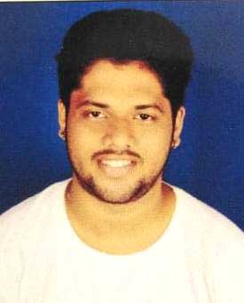
DEEPAK
Deepak-392898@2freemail.com
________________________________________________________________________

CAREER OBJECTIVE:
I wish to be a part of organization which will provide me challenging work and dynamic environment to utilize my best of knowledge and want to serve my best efforts towards growth of organization.
EDUCATIONAL QUALIFICATION
ACADEMIC | YEAR | BOARD
S.S.C | 2010 | NIOS
H.S.C | 2012 | NIOS

TECHNICAL KNOWLEDGE & SKILLS

- MS-CIT: Word, Advance Excel, PowerPoint.
- Typing Speed 35 WPM.

WORKING EXPERIENCE
- Worked with Schindler India Pvt Ltd as a Physical Fitness Trainer Since 2016 to 2018
- Worked with Rustomjee Club House as a Personal Trainer Since 2018 to 2019
- Free Lancing as a personal trainer in Various GYM’s since 2015 till date.
EXTRA ACTIVITIES

- Fitness Model.
- Fitness Programmer.
- Brand Influencer with Quick Nutrition.
- Sports Nutrition Counseling.
- Body Building Contest Prep.
- Body Building Athlete Supporter.

PERSONAL DETAILS
Date of Birth : 21st June, 1993.
Nationality : Indian.
Marital Status : Unmarried.
Gender : Male.
Language Known : English, Hindi & Marathi.
Hobbies : Body Building, Modeling.

